Telusko: Core Java 07

061 Collection in Java

Q>
Given:
1. public class Breaker2 {
2. static String o = "";
3.
4. public static void main(String[] args) {
5. z: for (int x = 2; x < 7; x++) {
6. if (x == 3)
7. continue;
8. if (x == 5)
9. break z;
10. o = o + x;
11. }
12. System.out.println(o);
13. }
14.}
15.
What is the result?
A. 2
B. 24
C. 234
D. 246
E. 2346
F. Compilation fails
x = 2 , 2<7(true)
2==3(false)
2==5(false)
o = "2"
x = 3, 3<7(true)
3==3(true)
x= 4, 4<7(true)
4==3(false)
4==5(false)
o ="24"
x= 5, 5<7(true)
5==3(false)
5==5(true)
Answer:B( "24")
Q>
Given:
1. public class GC {
2. private Object o;
3. private void doSomethingElse(Object obj) { o = obj; }
4. public void doSomething() {
5. Object o = new Object();
6. doSomethingElse(o);
7. o = new Object();
8. doSomethingElse(null);
9. o = null;
10. }
11.}
When the doSomething method is called, after which line does the Object created inline 5 become available for garbage collection?
A. Line 5
B. Line 6
C. Line 7
D. Line 8
E. Line 9
F. Line 10
Answer: D
Q>
Given:
1. interface DeclareStuff {
2. public static final int EASY = 3;
3.
4. void doStuff(int t);
5. }
6.
7. public class TestDeclare implements DeclareStuff {
8. public static void main(String[] args) {
9. int x = 5;
10. new TestDeclare().doStuff(++x);
11. }
12.
13. void doStuff(int s) {
14. s += EASY + ++s;
15. System.out.println("s " + s);
16. }
17.}
What is the result?
A. s 14
B. s 16
C. s 10
D. Compilation fails.
E. An exception is thrown at runtime.
Answer: D
QUESTION
Given:
public class Spock {
public static void main(String[] args) {
Long tail = 2000L;
Long distance = 1999L;
Long story = 1000L;
if ((tail > distance) ^ ((story * 2) == tail))// T ^ T = false
System.out.print("1");
if ((distance + 1 != tail) ^ ((story * 2) == distance))//F ^ F = false
System.out.print("2");
}
}
What is the result?
A. 1
B. 2
C. 12
D. Compilation fails.
E. No output is produced.
F. An exception is thrown at runtime.Answer: E
Q>
interface DoStuff2 {
float getRange(int low, int high);
}
interface DoMore {
float getAvg(int a, int b, int c);
}
abstract class DoAbstract implements DoStuff2, DoMore { class DoStuff implements DoStuff2 {//line-8
public float getRange(int x, int y) {
return 3.14f;
}
}//line-12
interface DoAll extends DoMore {//line-13
float getAvg(int a, int b, int c, int d);
}
What is the result?
A. The file will compile without error.
B. Compilation fails. Only line 7 contains an error.
C. Compilation fails. Only line 12 contains an error.
D. Compilation fails. Only line 13 contains an error.
E. Compilation fails. Only lines 7 and 12 contain errors.
F. Compilation fails. Only lines 7 and 13 contain errors.
G. Compilation fails. Lines 7, 12, and 13 contain errors.
Answer: A
Q>
}// line-7
class TestException extends Exception { //Exception public TestException() {
super();
}
public TestException(String s) {
super(s);
}
}
public class Test {
public void m1() throws __________ {
throw new TestException();
}
}
For the above code, fill in the blank with one option.
A. Exception
B. Object
C. RunTimeException
D. Error
=> Paritally checked Exception
2.
public class Test {
private static int [] arr; // arr =nullpublic static void main(String [] args) {
if(arr.length > 0 && arr != null) {
System.out.println(arr[0]);
}
}
}
java Test
Predict Output, if the above code is run with given command?
|
Test.main(new String[]{});
A. CompilationError
B. No Output is produced
C. NullPointerException is thrown at runtime
D. ArrayIndexOutOfBoundsException is thrown at runtime
Answer: C(arr.length -> gives NullPointerException)
3.
import java.io.FileNotFoundException;
import java.io.IOException;
abstract class Super {
public abstract void m1() throws IOException;
}
class Sub extends Super {
@Override
public void m1() throws IOException {
throw new FileNotFoundException();
}
}
public class Test {
public static void main(String[] args) {
Super s = new Sub();
try {
s.m1();
} catch (IOException e) {
System.out.print("A");
} catch(FileNotFoundException e) {
System.out.print("B");
} finally {
System.out.print("C");
}
}
}
A. AC
B. BC
C. class sub gives compilation error
D. class Test gives compilation error
Answer: D

import java.util.ArrayDeque;

public class LaunchAD {

public static void main(String[] args) {
// TODO Auto-generated method stub

ArrayDeque ad=new ArrayDeque();
ad.add(10);
ad.add(20);
ad.add(30);
ad.add(30);
System.out.println(ad);
ad.addFirst(5);
ad.addLast(35);
System.out.println(ad);

}

}

//To use any of the collection classes we need to import
import java.util.*;
public class LaunchAL1
{

public static void main(String[] args)
{
ArrayList al1=new ArrayList();
al1.add(10);
al1.add(20);
al1.add(30);
//homogenious type of data is allowed
System.out.println(al1);
System.out.println("********************");

ArrayList al2=new ArrayList();
al2.add("iNeuron");
al2.add(28);
al2.add('b');
al2.add(18.5);
al2.add(18.5);

System.out.println(al2);

System.out.println("************************");

// we can add entire collection into another collection
ArrayList al3=new ArrayList();
al3.addAll(al2);

System.out.println(al3);

System.out.println("*********************");

ArrayList al4=new ArrayList();
al4.add(11);
al4.add(22);
al4.add(33);
al4.add(44);
System.out.println("existing data " + al4);

al4.add(2, 28);

System.out.println("after adding in 2nd index "+al4);
al4.add(0, 5);

System.out.println("after adding in 0th index "+al4);

al4.add(55);

System.out.println("after adding in rear end "+al4);
al4.addAll(1, al2);
System.out.println(al4);

}

}
import java.util.ArrayList;

public class LaunchALIM {

public static void main(String[] args) {
ArrayList al4=new ArrayList();
al4.add(11);
al4.add(22);
al4.add(33);
al4.add(44);

System.out.println(al4);

// boolean res=al4.contains(44);
// System.out.println(res);
System.out.println(al4.contains(44));//true

int index=al4.indexOf(22);
System.out.println(index);//1

System.out.println(al4.isEmpty());
al4.ensureCapacity(10);
System.out.println(al4.size());
al4.trimToSize();
System.out.println(al4.getClass());

al4.clear();
System.out.println(al4);
System.out.println(al4.size());

}

}
import java.util.*;
public class LaunchLL {

public static void main(String[] args) {
// TODO Auto-generated method stub

LinkedList ll1=new LinkedList();

ll1.add(10);
ll1.add("iNeuron");
ll1.add("iNeuron");
ll1.add(20);
System.out.println(ll1);

ll1.addFirst("Hyder Abbas");
System.out.println(ll1);
ll1.add(3, "Bengaluru");

System.out.println(ll1);

ll1.addLast("RichMond town");

System.out.println(ll1);

System.out.println("***************************");

LinkedList ll2=new LinkedList();

ll2.add(10);
ll2.add(20);
ll2.add(40);
ll2.add(30);
ll2.add(40);
System.out.println(ll2);

System.out.println(ll2.getFirst());
System.out.println(ll2.getLast());
System.out.println(ll2.indexOf(40));
System.out.println(ll2.lastIndexOf(40));
// ll2.offerFirst(5);
// ll2.offerLast(55);
ll2.addFirst(5);
ll2.addLast(55);
System.out.println(ll2);
System.out.println(ll2.peekFirst());
System.out.println(ll2);
System.out.println(ll2.pollFirst());
System.out.println(ll2);

}

}
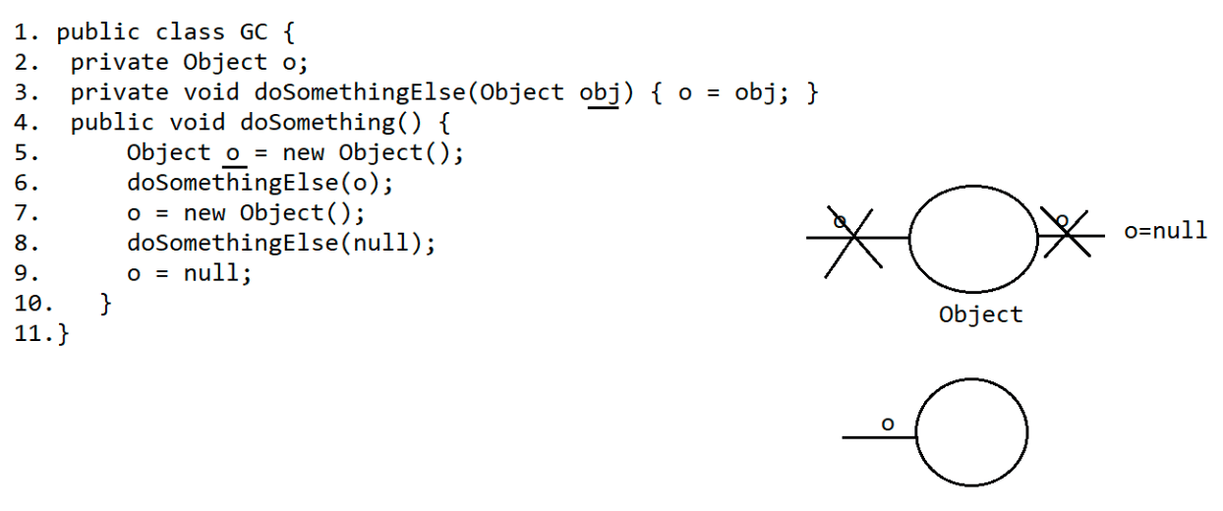
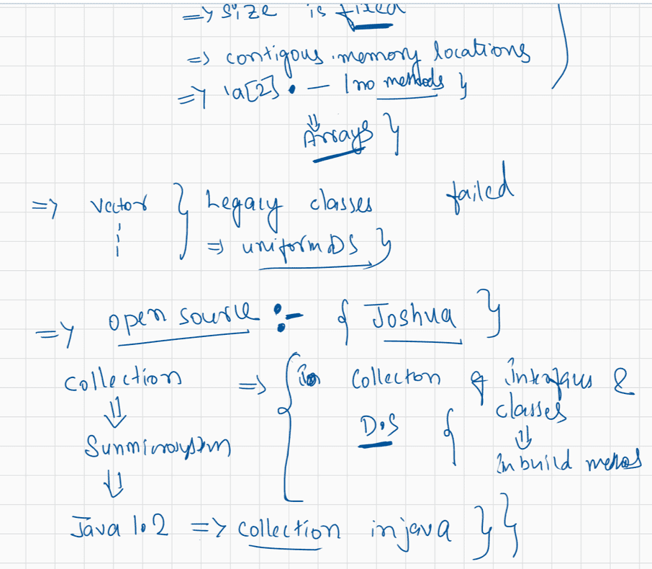
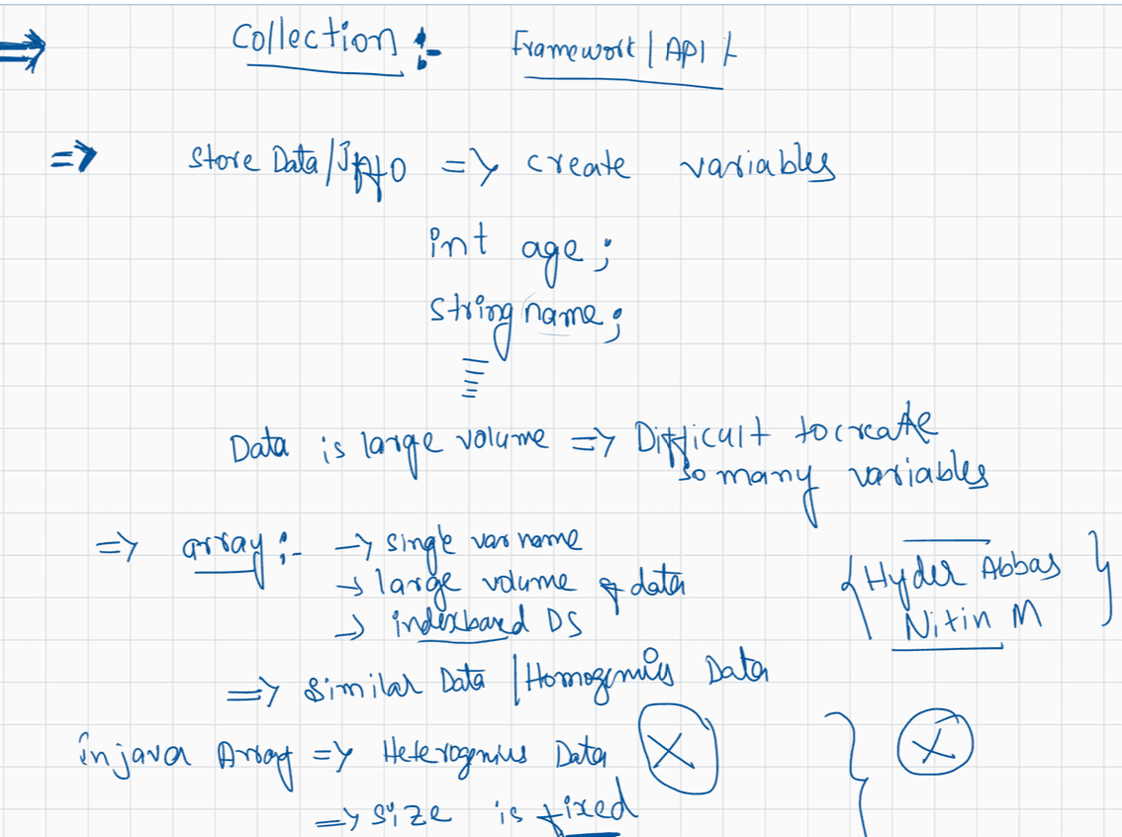
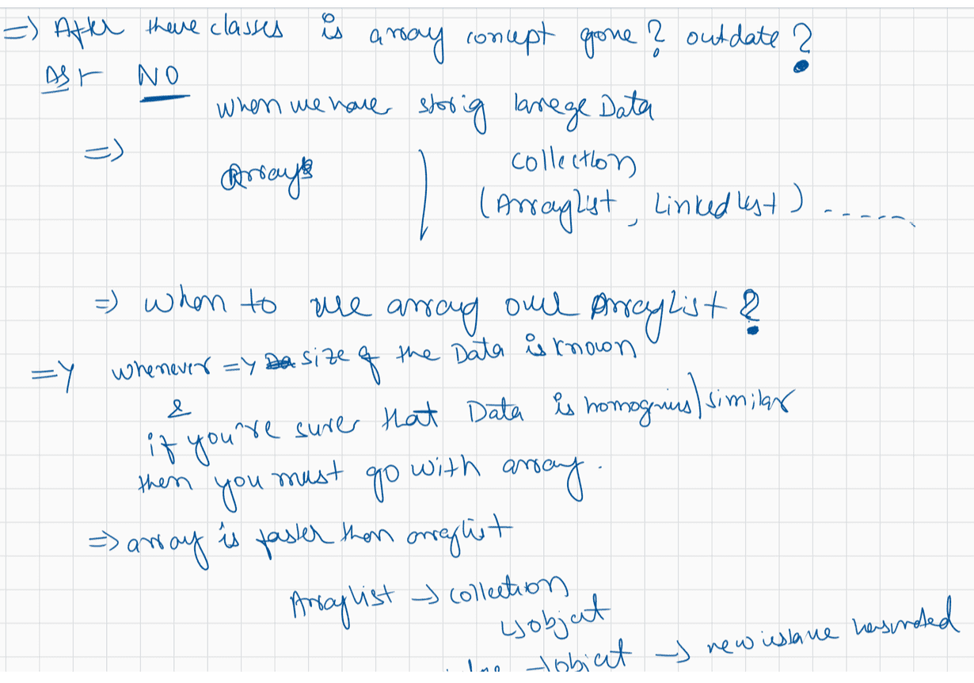
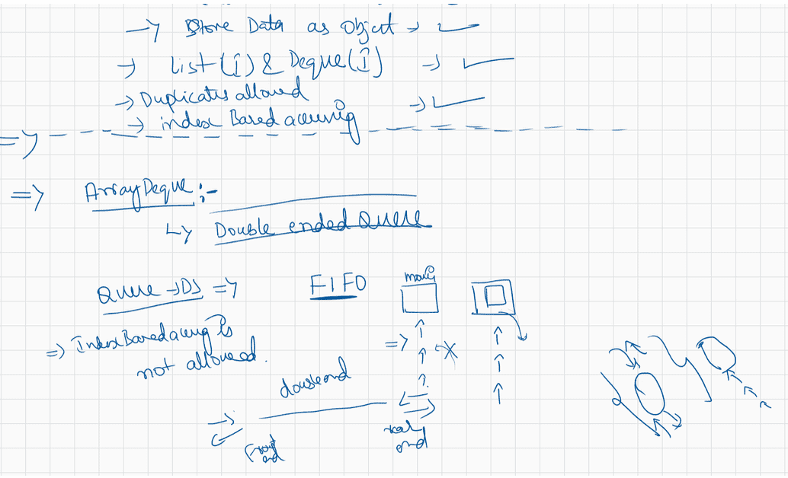
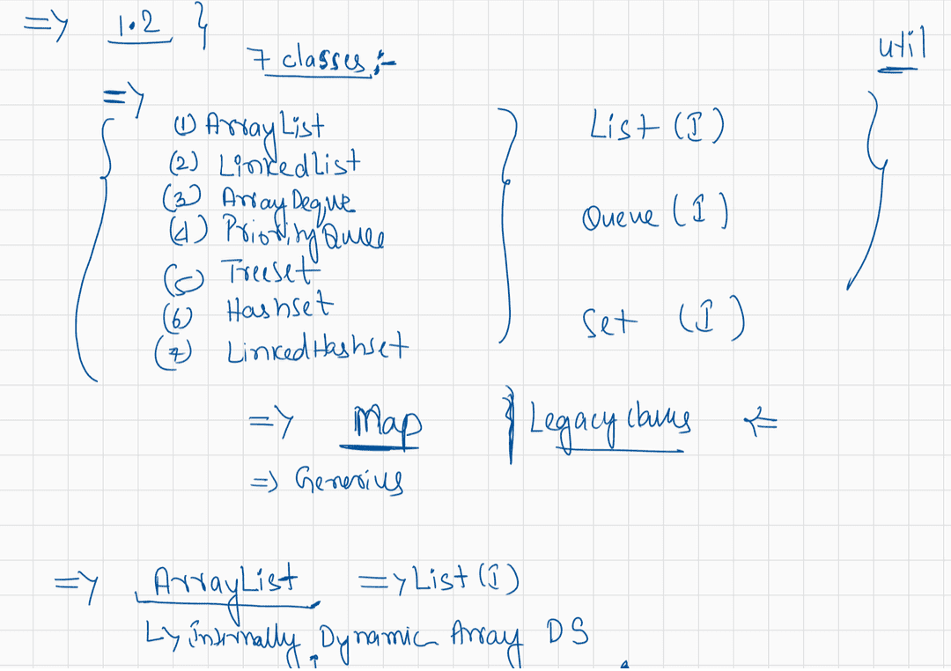
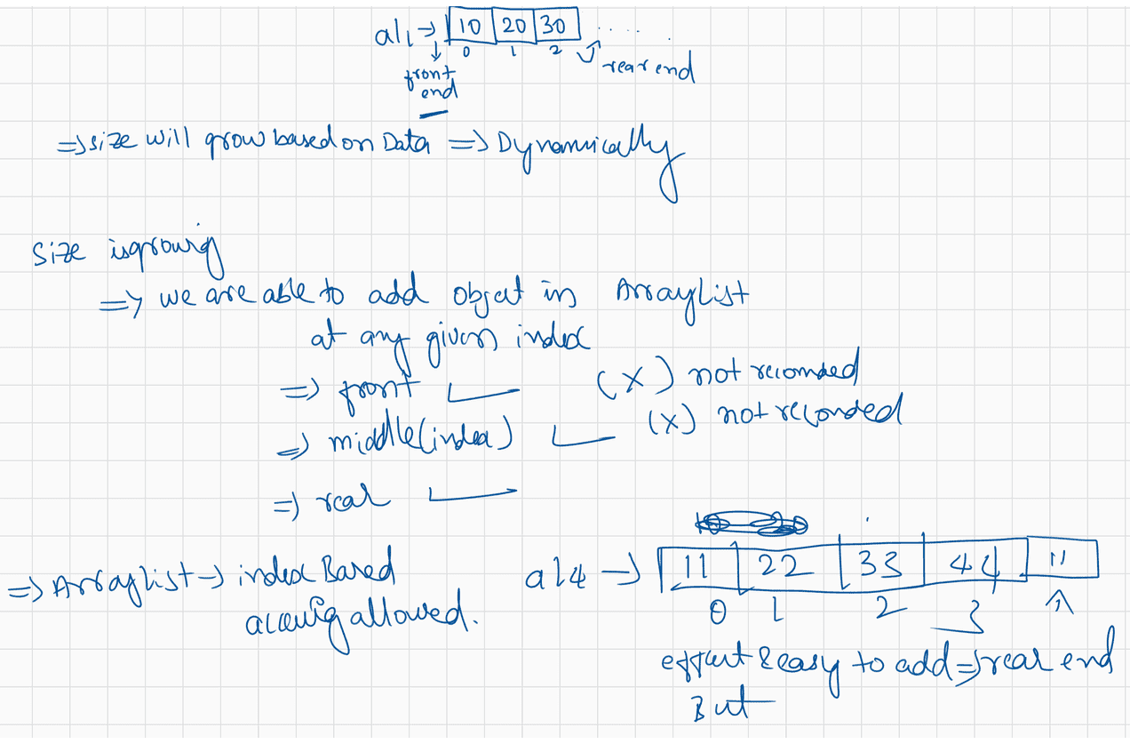
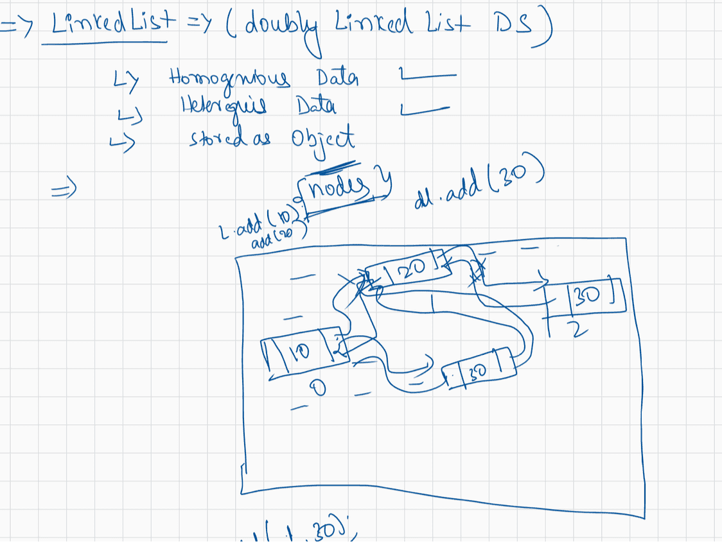
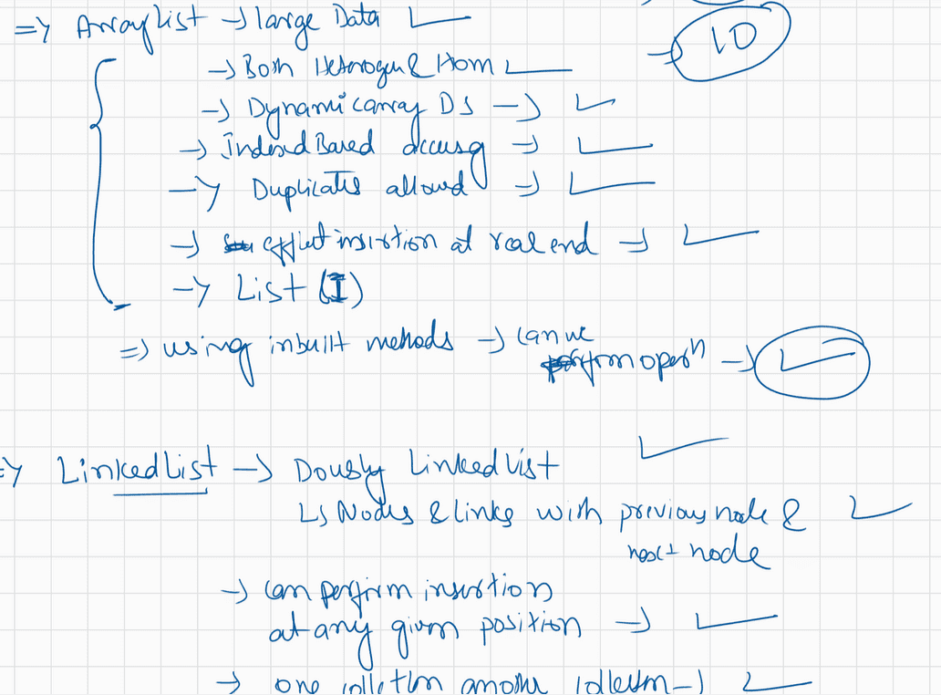

063 Collection in Java
import java.util.*;
public class LaunchHS {

public static void main(String[] args) {
// TODO Auto-generated method stub

HashSet hs=new HashSet();
hs.add(100);
hs.add(50);
hs.add(150);
hs.add(25);
hs.add(125);
System.out.println(hs);

LinkedHashSet lhs=new LinkedHashSet();
lhs.add(100);
lhs.add(50);
lhs.add(150);
lhs.add(25);
lhs.add(125);
System.out.println(lhs);
}

}
import java.util.ArrayDeque;
import java.util.ArrayList;
import java.util.Iterator;
import java.util.LinkedList;
import java.util.ListIterator;
import java.util.TreeSet;

public class LaunchImp {

public static void main(String[] args) {
// TODO Auto-generated method stub
ArrayList al=new ArrayList();
al.add(10); // al.add(new Integer(10));
al.add(10.5);//al.add(new Double(10.5));
al.add('c');//al.add(new Character('c'));
al.add(10.5f);// auto boxing
//System.out.println(al);

ArrayList al2=new ArrayList();
al2.add(10);
al2.add(20);
al2.add(30);
al2.add(40);
al2.add(50);
System.out.println(al2);//
//diff ways to access data present within collection
//loop normal
System.out.println(al2.size());
for(int i=0;i<al2.size();i++)
{
// Object o=al2.get(i);
// System.out.println(0);
System.out.print(al2.get(i)+ " ");
}
System.out.println();
//for each
for(Object obj:al2)
{
System.out.print(obj+ " ");
}
System.out.println("*************");
// iterator

Iterator itr1=al2.iterator();

// if(itr1.hasNext()==true)
// {
// itr1.next();
// }

while(itr1.hasNext())
{
// Integer i=(Integer) itr1.next();
//Object o=itr1.next();
System.out.println(itr1.next());

}
System.out.println("reverse");

ListIterator litr = al2.listIterator(al2.size());
while(litr.hasPrevious())
{
System.out.println(litr.previous());
}

// what if I want to reverse or access data of other claases in reverse dir?

TreeSet ad=new TreeSet();
ad.add(10);
ad.add(20);
ad.add(30);
ad.add(40);
Iterator it=ad.iterator();

while(it.hasNext()==true)
{
Integer i=(Integer) it.next();
System.out.println("Array De" + i);
}

System.out.println("added linked list");
LinkedList ll=new LinkedList();
ll.addAll(ad);
System.out.println(ll);

ListIterator litr2=ll.listIterator(ll.size());
System.out.println("Accessing treeset data in reverse");
while(litr2.hasPrevious())
{
System.out.println(litr2.previous());

}

}

}
import java.util.*;
public class LaunchPQ
{

public static void main(String[] args)
{

PriorityQueue pq=new PriorityQueue();
pq.add(100);
pq.add(50);
pq.add(150);
pq.add(25);
pq.add(75);
pq.add(125);
pq.add(175);
System.out.println(pq);
pq.add(25);
System.out.println(pq);

}

}
import java.util.*;
public class LaunchTS {

public static void main(String[] args)
{
TreeSet ts=new TreeSet();
ts.add(100);
ts.add(50);
ts.add(150);
ts.add(25);
ts.add(75);
ts.add(125);
ts.add(175);
System.out.println(ts);
System.out.println(ts.ceiling(50));
System.out.println(ts.higher(50));
System.out.println(ts.floor(50));
System.out.println(ts.lower(50));
System.out.println("******************");

System.out.println(ts.ceiling(40));
System.out.println(ts.higher(40));
System.out.println(ts.floor(40));
System.out.println(ts.lower(40));

}

}
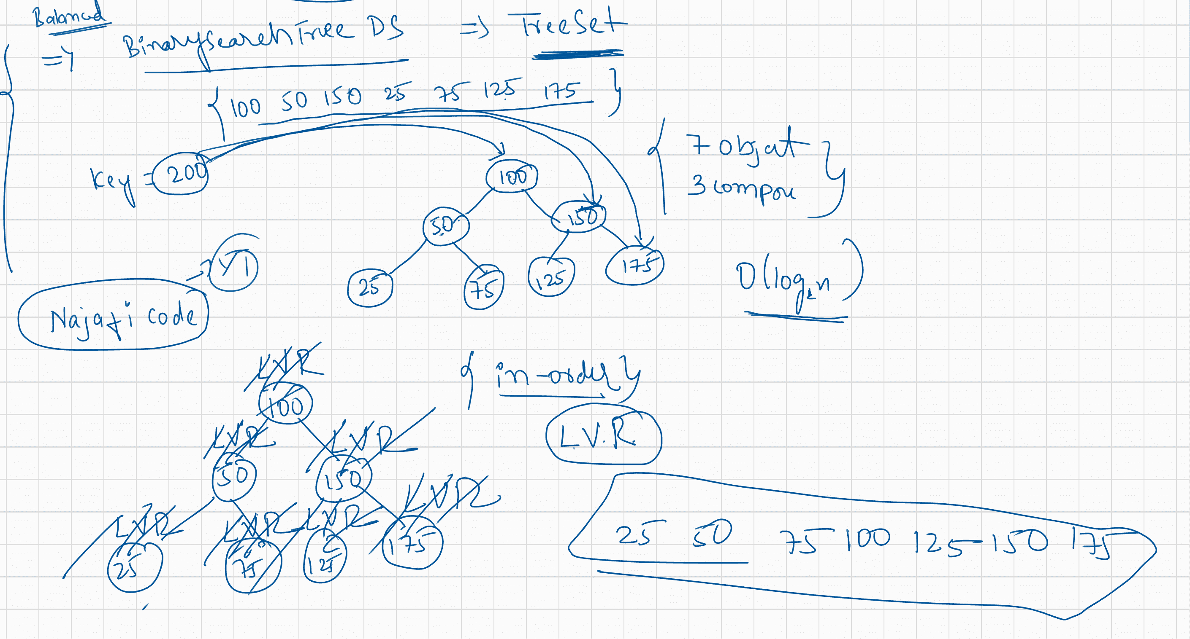
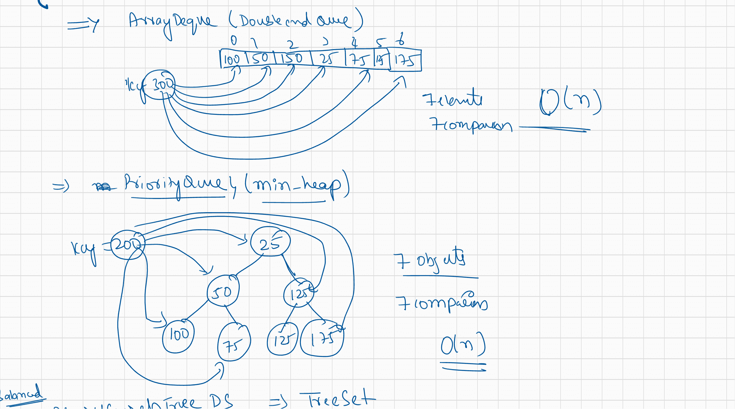
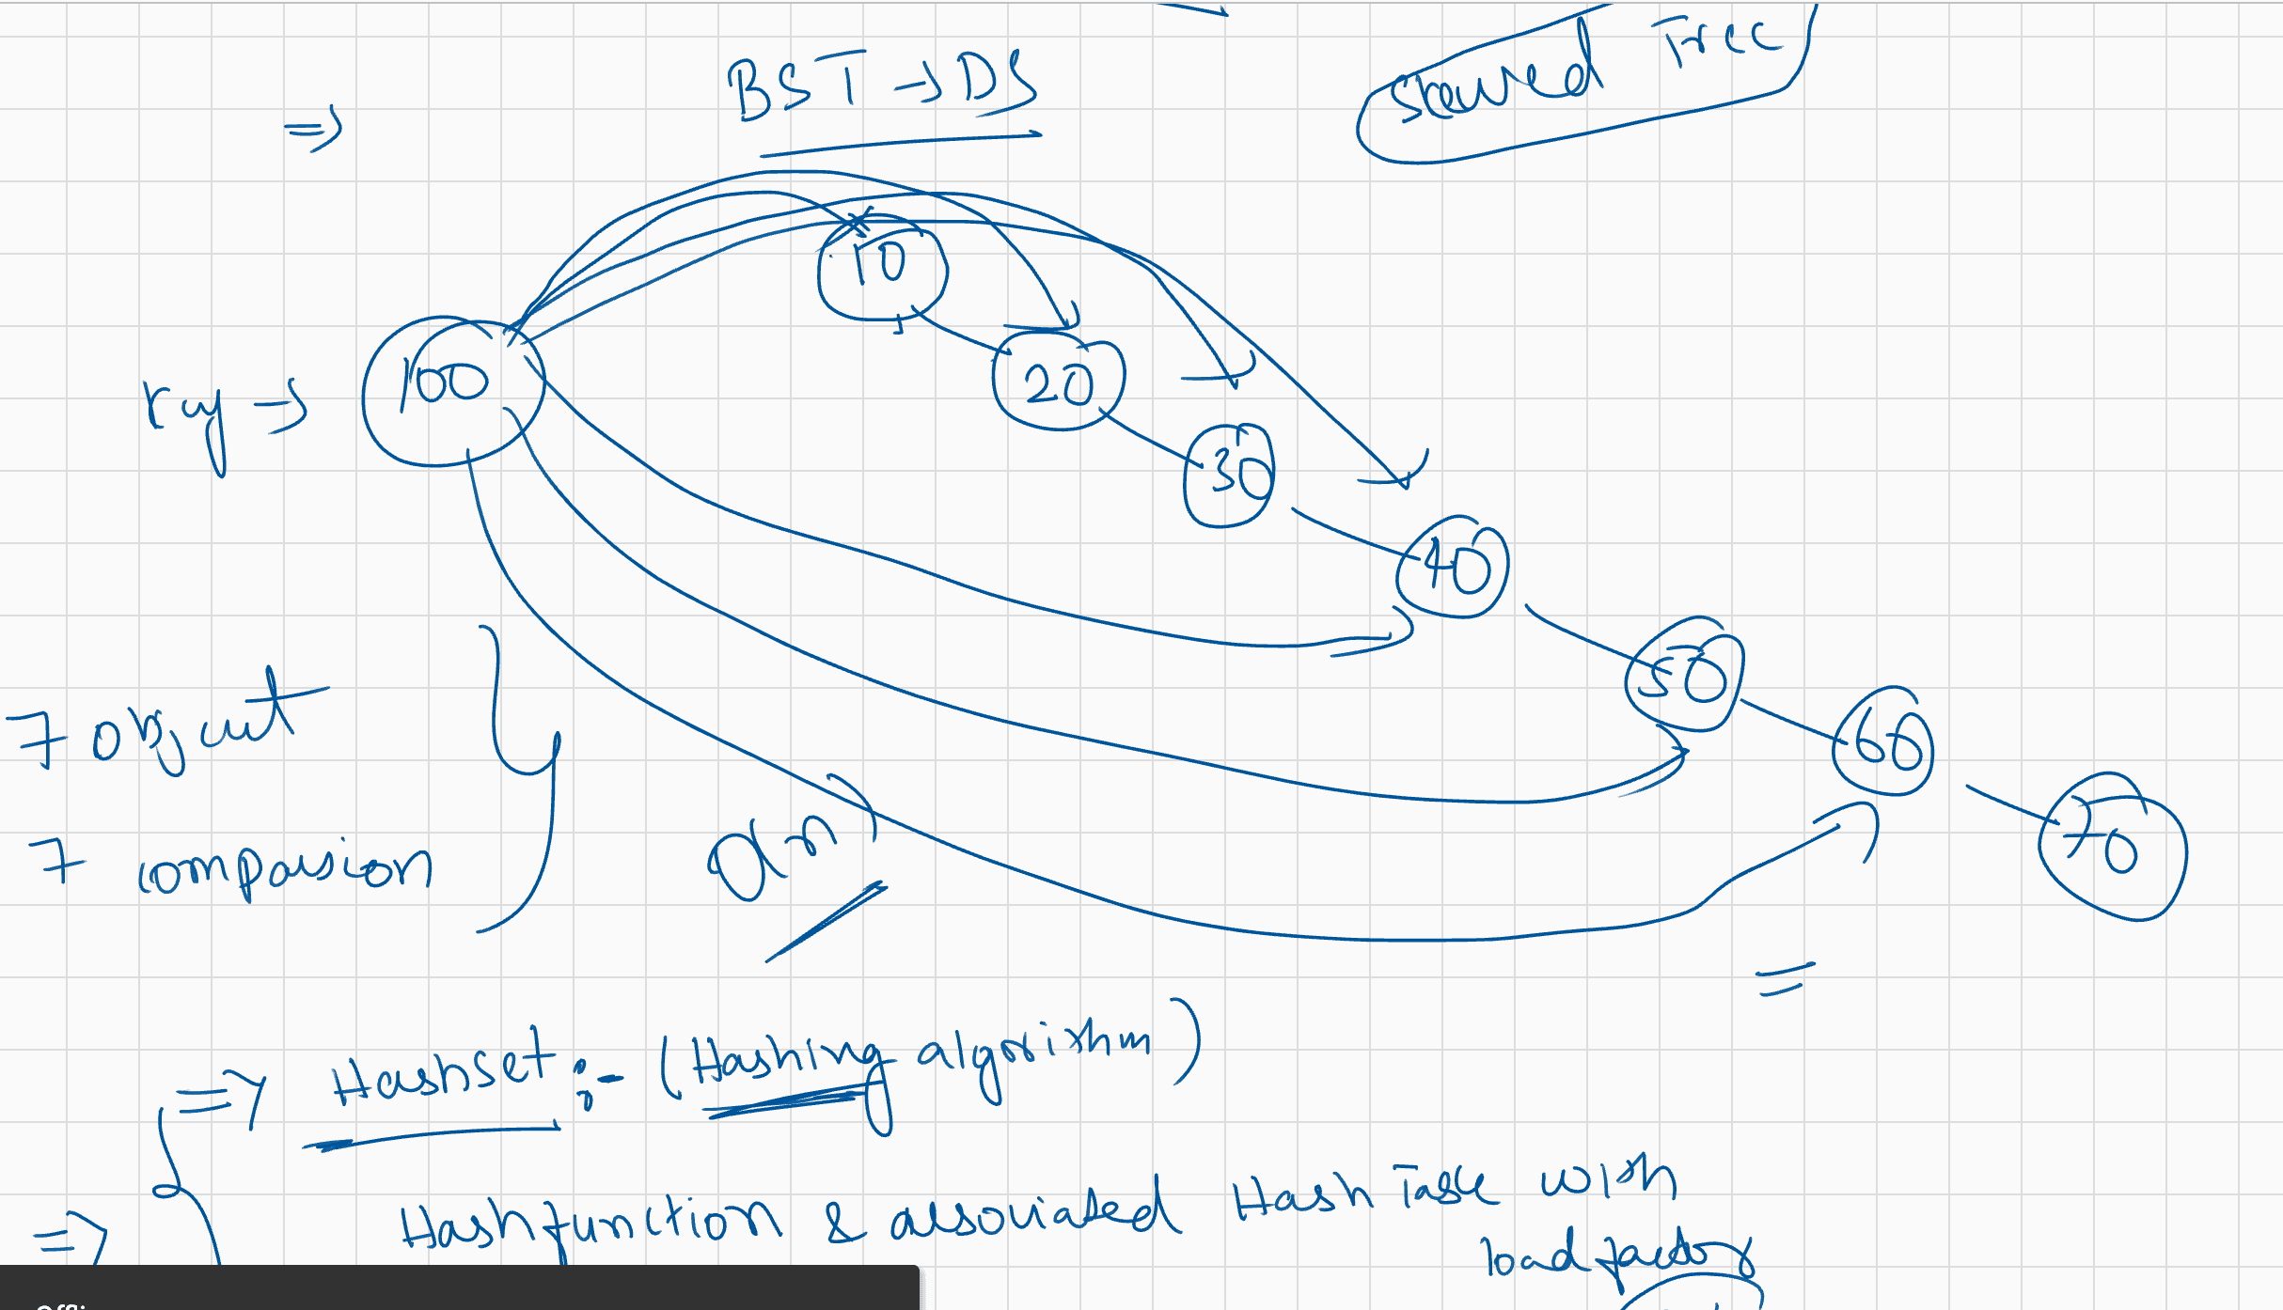

064 Collection In Java 3
Given:
class Plane {
static String s = "-";
public static void main(String[] args) {
new Plane().s1();
System.out.println(s);
}
void s1() {
try { s2(); }
catch (Exception e) { s += "c"; }
}
void s2() throws Exception {
s3(); s += "2";
s3(); s += "2b";
void s3() throws Exception {
throw new Exception();
}
}
}
What is the result?
A. -
B. -c
C. -c2
D. -2c
E. -c22b
F. -2c2b
G. -2c2bc
H. Compilation fails
Answer: B
Given:
try { int x = Integer.parseInt("two"); }
Which could be used to create an appropriate catch block? (Choose all that apply.)
A. ClassCastException
B. IllegalStateException
C. NumberFormatException
D. IllegalArgumentException
E. ExceptionInInitializerError
F. ArrayIndexOutOfBoundsException
answer: C,D
Q> Given:
1. class Loopy {
2. public static void main(String[] args) {
3. int[] x = {7,6,5,4,3,2,1};
4. // insert code here
5. System.out.print(y + " ");
6. }
7. }
}
Which, inserted independently at line 4, compiles? (Choose all that apply.)
A. for(int y : x) {
B. for(x : int y) {
C. int y = 0; for(y : x) {
D. for(int y=0, z=0; z<x.length; z++) { y = x[z];
E. for(int y=0, int z=0; z<x.length; z++) { y = x[z];
F. int y = 0; for(int z=0; z<x.length; z++) { y = x[z];answer: A, D,F
Q>
Given:
class Emu {
static String s = "-";// -ic mc mf of
public static void main(String[] args) {
try
{
}
throw new Exception();
catch (Exception e) {
try
{
try
{
throw new Exception();
}
catch (Exception ex) {
s += "ic ";
}
throw new Exception();
}
catch (Exception x)
{
s += "mc ";
}
finally
{
s += "mf ";
}
}
finally
{
s += "of ";
}
System.out.println(s);
}
}
What is the result?
A. -ic of
B. -mf of
C. -mc mf
D. -ic mf of
E. -ic mc mf of
F. -ic mc of mf
G. Compilation fails
Answer: E
Q>
Given:
3. class SubException extends Exception { }//Parentexception type
4. class SubSubException extends SubException { }//Childexception type
5.
6. public class CC { void doStuff() throws SubException { } }//Parent
7.
8. class CC2 extends CC { void doStuff() throws SubSubException { } }//Child9.
10. class CC3 extends CC { void doStuff() throws Exception { } }//Child::CE(voilate
the rule of overriding)
11.
12. class CC4 extends CC { void doStuff(int x) throws Exception { } }//child
13.
14. class CC5 extends CC { void doStuff() { } }//Child
What is the result? (Choose all that apply.)
A. Compilation succeeds
B. Compilation fails due to an error on line 8
C. Compilation fails due to an error on line 10
D. Compilation fails due to an error on line 12
E. Compilation fails due to an error on line 14
Answer: C
Given:
3. public class Ebb {
4. static int x = 7;// x = 7, 8,9 ,10,11
5. public static void main(String[] args) {
6. String s = ""; // s = 9 10 10 d 13
7. for(int y = 0; y < 3; y++) {// y = 0,1,2,3
8. x++;
9. switch(x) {
10. case 8: s += "8 ";
11. case 9: s += "9 ";
12. case 10: { s+= "10 "; break; }
13. default: s += "d ";
14. case 13: s+= "13 ";
15. }
16. }
17. System.out.println(s);
18. }
19. static { x++; }
20. }
What is the result?
A. 9 10 d
B. 8 9 10 d
C. 9 10 10 d
D. 9 10 10 d 13
E. 8 9 10 10 d 13
F. 8 9 10 9 10 10 d 13
G. Compilation fails
answer: D
Given:
3. class Infinity { }
4. public class Beyond extends Infinity {
5. static Integer i; // i =null
6. public static void main(String[] args) {
7. int sw = (int)(Math.random() * 3);
8. switch(sw) {
9. 10. case 0: { for(int x = 10; x > 5; x++)
if(x > 10000000) x = 10;
11. break; }
case 1: { int y = 7 * i; break; }12. 13. 14. case 2: { Infinity inf = new Beyond();
Beyond b = (Beyond)inf; }
15. }
16. }
17. }
And given that line 7 will assign the value 0, 1, or 2 to sw, which are true?
(Choose all that apply.)
A. Compilation fails
B. A ClassCastException might be thrown
C. A StackOverflowError might be thrown
D. A NullPointerException might be thrown
E. An IllegalStateException might be thrown
F. The program might hang without ever completing
G. The program will always complete without exception
Answer: D,F

import java.util.Enumeration;
import java.util.Vector;

public class LaunchV {

public static void main(String[] args) {
// TODO Auto-generated method stub

Vector v=new Vector();
v.add(100);
v.add(200);
v.add(300);
v.add(400);
v.add(500);

Enumeration em=v.elements();
while(em.hasMoreElements())
{
System.out.println(em.nextElement());
}
}

}

import java.util.*;
public class LaunchPolC {

public static void main(String[] args) {
// TODO Auto-generated method stub

//ArrayList al=new ArrayList();
List list=new ArrayList();

Queue q=new ArrayDeque();

List li=new LinkedList();

Deque ql=new LinkedList();

Set set=new HashSet();

}

}
import java.util.ArrayDeque;
import java.util.ArrayList;
import java.util.Iterator;
import java.util.LinkedList;
import java.util.ListIterator;
import java.util.TreeSet;

public class LaunchImp {

public static void main(String[] args) {
// TODO Auto-generated method stub
ArrayList al=new ArrayList();
al.add(10); // al.add(new Integer(10));
al.add(10.5);//al.add(new Double(10.5));
al.add('c');//al.add(new Character('c'));
al.add(10.5f);// auto boxing
//System.out.println(al);

ArrayList al2=new ArrayList();
al2.add(10);
al2.add(20);
al2.add(30);
al2.add(40);
al2.add(50);
System.out.println(al2);//
//diff ways to access data present within collection
//loop normal
System.out.println(al2.size());
for(int i=0;i<al2.size();i++)
{
// Object o=al2.get(i);
// System.out.println(0);
System.out.print(al2.get(i)+ " ");
}
System.out.println();
//for each
for(Object obj:al2)
{
System.out.print(obj+ " ");
}
System.out.println("*************");
// iterator

Iterator itr1=al2.iterator();

// if(itr1.hasNext()==true)
// {
// itr1.next();
// }

while(itr1.hasNext())
{
// Integer i=(Integer) itr1.next();
//Object o=itr1.next();
System.out.println(itr1.next());

}
System.out.println("reverse");

ListIterator litr = al2.listIterator(al2.size());
while(litr.hasPrevious())
{
System.out.println(litr.previous());
}

// what if I want to reverse or access data of other claases in reverse dir?

TreeSet ad=new TreeSet();
ad.add(10);
ad.add(20);
ad.add(30);
ad.add(40);
Iterator it=ad.iterator();

while(it.hasNext()==true)
{
Integer i=(Integer) it.next();
System.out.println("Array De" + i);
}

System.out.println("added linked list");
LinkedList ll=new LinkedList();
ll.addAll(ad);
System.out.println(ll);

ListIterator litr2=ll.listIterator(ll.size());
System.out.println("Accessing treeset data in reverse");
while(litr2.hasPrevious())
{
System.out.println(litr2.previous());

}

/// LinkedList, ArrayDeque and TreeSet

LinkedList ll2=new LinkedList();
ll2.add(100);
ll2.add(200);
ll2.add(300);
ll2.add(400);
ll2.add(500);
System.out.println(ll2);

Iterator ditr=ll2.descendingIterator();

while(ditr.hasNext())
{
//Integer i=(Integer) ditr.next();
System.out.print( ditr.next()+ " ");
}

}

}
import java.util.*;
class Student
{
private int age;
private int marks;
private String name;

public Student(int age,int marks,String name)
{
this.age=age;
this.marks=marks;
this.name=name;
}
public int getAge() {
return age;
}
public int getMarks() {
return marks;
}
public String getName() {
return name;
}
}
public class LaunchGen {

public static void main(String[] args) {
// TODO Auto-generated method stub

Student s1=new Student(12, 75, "Rahul");
Student s2=new Student(14, 99, "Sharmaji ka beta");
Student s3=new Student(12, 75, "Rohan");

ArrayList<Student> al=new ArrayList<Student>();
al.add(s1);
al.add(s2);
al.add(s3);
//al.add(100); error
//al.add("hgfdfgh"); error

System.out.println(al);

}

}
import java.util.*;
import java.util.concurrent.CopyOnWriteArrayList;
public class LaunchFFFS {

public static void main(String[] args)
{
// TODO Auto-generated method stub

ArrayList al=new ArrayList();

al.add(100);
al.add(200);
al.add(300);
al.add(400);
al.add(500);

// for(int i=0 ;i<al.size();i++)
// {
// System.out.println(al.get(i));
// al.add(10);
// }

//Fail Fast
Iterator itr=al.iterator();

while(itr.hasNext())
{
System.out.println(itr.next());
//al.add(123);
}

//Failsafe

CopyOnWriteArrayList cal=new CopyOnWriteArrayList();

cal.add(1000);
cal.add(2000);
cal.add(3000);
cal.add(4000);

Iterator itrr=cal.iterator();
while(itrr.hasNext())
{
System.out.println(itrr.next());
cal.add(12345);
}

}

}
import java.util.*;
public class LaunchCollections {

public static void main(String[] args)
{
// TODO Auto-generated method stub
// 100 50 150 25 75 125 175

TreeSet ts=new TreeSet();

ts.add(100);
ts.add(50);
ts.add(150);
ts.add(25);
ts.add(75);
ts.add(125);
ts.add(175);

System.out.println(ts);

ArrayList al=new ArrayList();
al.add(100);
al.add(50);
al.add(150);
al.add(25);
al.add(75);
al.add(125);
al.add(175);
System.out.println(al);

//Collection vs Collections

Collections.sort(al);

System.out.println(al);

ArrayList<String> al2=new ArrayList<String>();
// al2.add(28); error
al2.add("Hyder");
al2.add("ineuron");
al2.add("Najafi code");
//error al2.add(560025);

Collections.sort(al2);
System.out.println(al2);

ArrayList<Integer> al3=new ArrayList<Integer>();
al3.add(1000);
al3.add(200);
// al3.add("GF"); error
Collections.sort(al3);
System.out.println(al3);

//few more important inbuit methods of Collections class

ArrayList al4=new ArrayList();
al4.add(10);
al4.add(20);
al4.add(30);
al4.add(40);
al4.add(50);
int index= Collections.binarySearch(al4, 40);
System.out.println("Index " + index);

Collections.shuffle(al4);
System.out.println(al4);

System.out.println(Collections.frequency(al4, 40));

}

}
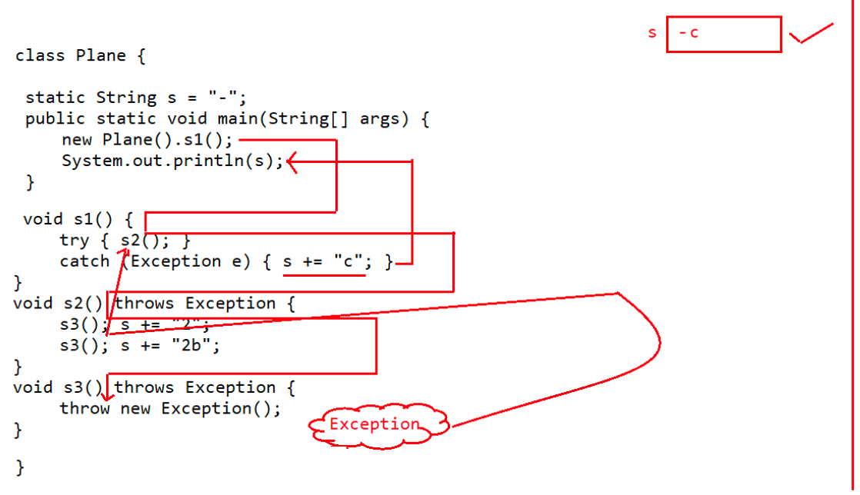
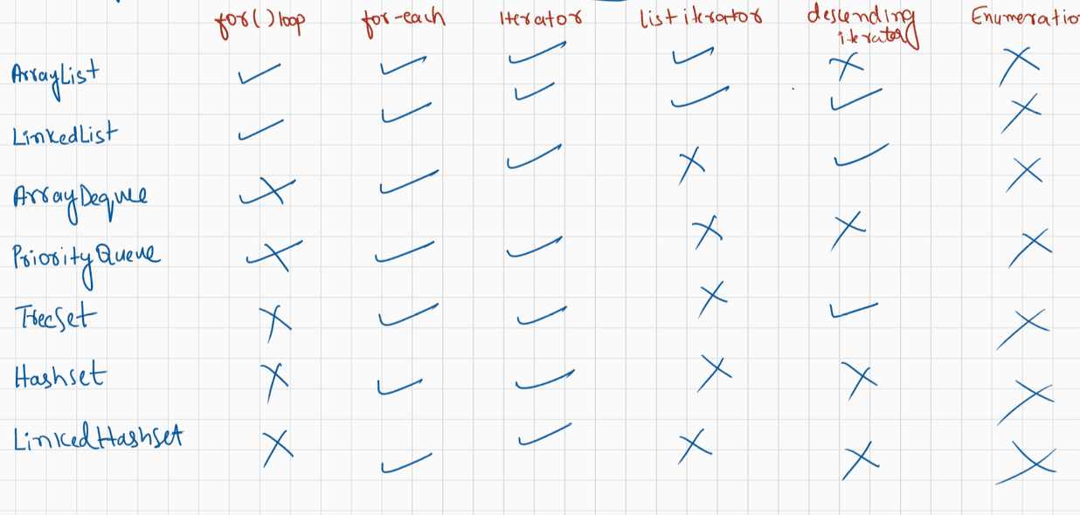
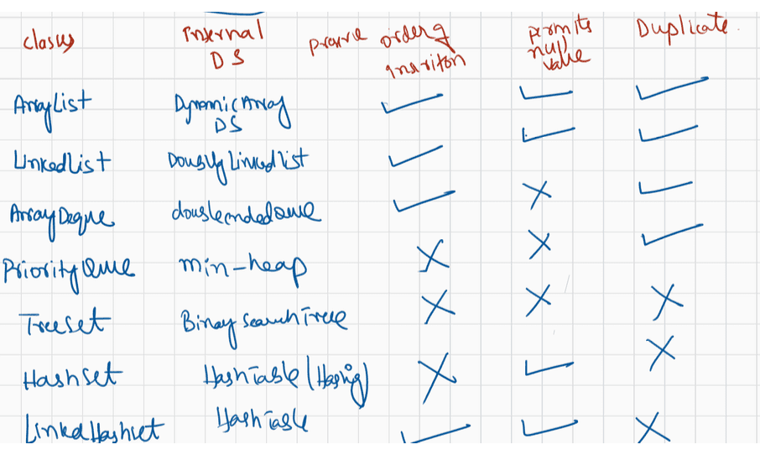

066 Map in Java
Given:
3. public class Circles {
4. public static void main(String[] args) {
5. int[] ia = {1,3,5,7,9};
6. for(int x : ia) {// x= 1,3,5,7,9
7. for(int j = 0; j < 3; j++) {// j = 0,1
8. if(x > 4 && x < 8) continue;
9. System.out.print(" " + x);//1 1 3 3 9 9
10. if(j == 1) break;
11. continue;
12. }
13. continue;
14. }
15. }
16. }
What is the result?
A. 1 3 9
B. 5 5 7 7
C. 1 3 3 9 9
D. 1 1 3 3 9 9
E. 1 1 1 3 3 3 9 9 9
F. Compilation fails
Answer: D
11. Given:
3. public class OverAndOver {
4. static String s = "";
5. public static void main(String[] args) {
6. try {
7. s += "1";// 1
8. throw new Exception();
9. } catch (Exception e) { s += "2"; // 12
10. } finally {
s += "3"; // 123
doStuff(); //java.lang.ArithemticException
s += "4";
11. }
12. System.out.println(s);
13. }
14. static void doStuff() { int x = 0; int y = 7/x;
}//java.lang.ArithmeticException
15. }
What is the result?
A. 12
B. 13
C. 123
D. 1234
E. Compilation fails
F. 123 followed by an exception
G. 1234 followed by an exception
H. An exception is thrown with no other output
Answer: H
Given:
3. public class Wind {4. public static void main(String[] args) {
5. foreach:
6. for(int j=0; j<5; j++) {// j = 0,1,2,3
7. for(int k=0; k< 3; k++) {// k = 0,1
8. System.out.print(" " + j);// 0 1 1 1 2 3 3
9. if(j==3 && k==1) break foreach;
10. if(j==0 || j==2) break;
11. }
12. }
13. }
14. }
What is the result?
A. 0 1 2 3
B. 1 1 1 3 3
C. 0 1 1 1 2 3 3
D. 1 1 1 3 3 4 4 4
E. 0 1 1 1 2 3 3 4 4 4
F. Compilation fails
Answer: C
Given:
3. public class Gotcha {
4. public static void main(String[] args) {
5. // insert code here
6.
7. }
8. void go() {
9. go();
10. }
11. }
And given the following three code fragments:
I. new Gotcha().go();
II. try { new Gotcha().go(); }
catch (Error e) { System.out.println("ouch"); }
III. try { new Gotcha().go(); }
catch (Exception e) { System.out.println("ouch"); }
When fragments I - III are added, independently, at line 5, which are true?
(Choose all that apply.)
A. Some will not compile
B. They will all compile
C. All will complete normally
D. None will complete normally
E. Only one will complete normally
F. Two of them will complete normally
Answer: B,E(option ii will be completed properly)
Q>
Given:
import java.io.*;
1. public class Frisbee {
2. // insert code here
3. int x = 0;
4. System.out.println(7/x);
5. }
6. }And given the following four code fragments:
I. public static void main(String[] args) {
II. public static void main(String[] args) throws Exception {
III. public static void main(String[] args) throws IOException {
IV. public static void main(String[] args) throws RuntimeException {
If the four fragments are inserted independently at line 2, which are true? (Choose
all that apply.)
A. All four will compile and execute without exception
B. All four will compile and execute and throw an exception
C. Some, but not all, will compile and execute without exception
D. Some, but not all, will compile and execute and throw an exception
E. When considering fragments II, III, and IV, of those that will compile, adding
a try/catch
block around line 6 will cause compilation to fail.
i,ii,iii,iv will compile and at the runtime throws ArithmeticException.
Answer:: B
Given:
2. class MyException extends Exception { }//MyException is a
checkedException(partially checked one) only.
3. class Tire {
4. void doStuff() { }
5. }
6. public class Retread extends Tire {
7. public static void main(String[] args) {
8. new Retread().doStuff();
9. }
10. // insert code here
11. System.out.println(7/0);//ArithmeticException(uncheckedException)
12. }
13. }
And given the following four code fragments:
I. void doStuff() {
II. void doStuff() throws MyException {
III. void doStuff() throws RuntimeException {
IV. void doStuff() throws ArithmeticException {
When fragments I - IV are added, independently, at line 10, which are true? (Choose
all that apply.)
A. None will compile
B. They will all compile
C. Some, but not all, will compile
D. All of those that compile will throw an exception at runtime
E. None of those that compile will throw an exception at runtime
F. Only some of those that compile will throw an exception at runtime
i valid
ii CE
iii valid
iv valid
Answer: C,D

Given:
class Plane {
static String s = "-";
public static void main(String[] args) {
new Plane().s1();
System.out.println(s);
}
void s1() {
try { s2(); }
catch (Exception e) { s += "c"; }
}
void s2() throws Exception {
s3(); s += "2";
s3(); s += "2b";
void s3() throws Exception {
throw new Exception();
}
}
}
What is the result?
A. -
B. -c
C. -c2
D. -2c
E. -c22b
F. -2c2b
G. -2c2bc
H. Compilation fails
Answer: B
Given:
try { int x = Integer.parseInt("two"); }
Which could be used to create an appropriate catch block? (Choose all that apply.)
A. ClassCastException
B. IllegalStateException
C. NumberFormatException
D. IllegalArgumentException
E. ExceptionInInitializerError
F. ArrayIndexOutOfBoundsException
answer: C,D
Q> Given:
1. class Loopy {
2. public static void main(String[] args) {
3. int[] x = {7,6,5,4,3,2,1};
4. // insert code here
5. System.out.print(y + " ");
6. }
7. }
}
Which, inserted independently at line 4, compiles? (Choose all that apply.)
A. for(int y : x) {
B. for(x : int y) {
C. int y = 0; for(y : x) {
D. for(int y=0, z=0; z<x.length; z++) { y = x[z];
E. for(int y=0, int z=0; z<x.length; z++) { y = x[z];
F. int y = 0; for(int z=0; z<x.length; z++) { y = x[z];answer: A, D,F
Q>
Given:
class Emu {
static String s = "-";// -ic mc mf of
public static void main(String[] args) {
try
{
}
throw new Exception();
catch (Exception e) {
try
{
try
{
throw new Exception();
}
catch (Exception ex) {
s += "ic ";
}
throw new Exception();
}
catch (Exception x)
{
s += "mc ";
}
finally
{
s += "mf ";
}
}
finally
{
s += "of ";
}
System.out.println(s);
}
}
What is the result?
A. -ic of
B. -mf of
C. -mc mf
D. -ic mf of
E. -ic mc mf of
F. -ic mc of mf
G. Compilation fails
Answer: E
Q>
Given:
3. class SubException extends Exception { }//Parentexception type
4. class SubSubException extends SubException { }//Childexception type
5.
6. public class CC { void doStuff() throws SubException { } }//Parent
7.
8. class CC2 extends CC { void doStuff() throws SubSubException { } }//Child9.
10. class CC3 extends CC { void doStuff() throws Exception { } }//Child::CE(voilate
the rule of overriding)
11.
12. class CC4 extends CC { void doStuff(int x) throws Exception { } }//child
13.
14. class CC5 extends CC { void doStuff() { } }//Child
What is the result? (Choose all that apply.)
A. Compilation succeeds
B. Compilation fails due to an error on line 8
C. Compilation fails due to an error on line 10
D. Compilation fails due to an error on line 12
E. Compilation fails due to an error on line 14
Answer: C
Given:
3. public class Ebb {
4. static int x = 7;// x = 7, 8,9 ,10,11
5. public static void main(String[] args) {
6. String s = ""; // s = 9 10 10 d 13
7. for(int y = 0; y < 3; y++) {// y = 0,1,2,3
8. x++;
9. switch(x) {
10. case 8: s += "8 ";
11. case 9: s += "9 ";
12. case 10: { s+= "10 "; break; }
13. default: s += "d ";
14. case 13: s+= "13 ";
15. }
16. }
17. System.out.println(s);
18. }
19. static { x++; }
20. }
What is the result?
A. 9 10 d
B. 8 9 10 d
C. 9 10 10 d
D. 9 10 10 d 13
E. 8 9 10 10 d 13
F. 8 9 10 9 10 10 d 13
G. Compilation fails
answer: D
Given:
3. class Infinity { }
4. public class Beyond extends Infinity {
5. static Integer i; // i =null
6. public static void main(String[] args) {
7. int sw = (int)(Math.random() * 3);
8. switch(sw) {
9. 10. case 0: { for(int x = 10; x > 5; x++)
if(x > 10000000) x = 10;
11. break; }
case 1: { int y = 7 * i; break; }12. 13. 14. case 2: { Infinity inf = new Beyond();
Beyond b = (Beyond)inf; }
15. }
16. }
17. }
And given that line 7 will assign the value 0, 1, or 2 to sw, which are true?
(Choose all that apply.)
A. Compilation fails
B. A ClassCastException might be thrown
C. A StackOverflowError might be thrown
D. A NullPointerException might be thrown
E. An IllegalStateException might be thrown
F. The program might hang without ever completing
G. The program will always complete without exception
Answer: D,F

import java.util.*;
import java.util.Map.Entry;

public class LaunchMaps {

public static void main(String[] args) {
// TODO Auto-generated method stub

//Map hm=new HashMap();
//jdk 1.2
//order of insertioin is not preserved
HashMap hm=new HashMap();
hm.put(10, "Sachin");//Entry
hm.put(7, "MSD");
hm.put(18, "Kohli");

System.out.println(hm);

System.out.println(hm.get(10) +" after this");
System.out.println("********************");
System.out.println("********************");
Collection c=hm.values();
Iterator itr=c.iterator();
while(itr.hasNext())
{
//System.out.println(itr.next());
String o=(String) itr.next();
System.out.println(o);

}
System.out.println("********************");
System.out.println("********************");
Set s=hm.keySet();

Iterator itr2=s.iterator();
while(itr2.hasNext())
{
// System.out.println(itr2.next());
Integer i=(Integer) itr2.next();
System.out.println("key : " + i);

}
System.out.println("********************");
System.out.println("********************");

Set es=hm.entrySet();
Iterator itr3=es.iterator();
while(itr3.hasNext())
{
// System.out.println(itr3.next());
Map.Entry data =(Entry) itr3.next();
System.out.println(data.getKey()+ " :" + data.getValue());
}
System.out.println("********************");
System.out.println("********************");
//jdk 1.4
//maintains order of insertion
LinkedHashMap lhm=new LinkedHashMap();
lhm.put(10, "Sachin");
lhm.put(7, "MSD");
lhm.put(18, "Kohli");

System.out.println(lhm);
}

}
import java.util.*;
import java.util.Map.Entry;
class Student1
{
private String name;
private int age;
private String city;

public Student1(String name, int age, String city)
{
this.name=name;
this.age=age;
this.city=city;
}
public String getName() {
return name;
}
public int getAge() {
return age;
}
public String getCity() {
return city;
}
@Override
public String toString()
{
return name + " " +age + " " + city ;
}
}
public class LaunchMapsCom {

public static void main(String[] args) {
// TODO Auto-generated method stub

Student1 st1=new Student1("Rohan", 18, "Mumbai");
Student1 st2=new Student1("Rahul", 18, "Bengaluru");
Student1 st3=new Student1("Rohan", 19, "Delhi");

HashMap hm=new HashMap();
hm.put(1, st1);
hm.put(2, st2);
hm.put(3, st3);

System.out.println(hm);

//view

//entryset

Collection col=hm.values();
Iterator itr=col.iterator();
while(itr.hasNext())
{
System.out.println("value of Student : "+ itr.next());
}

System.out.println("**********************");

Set set=hm.keySet();

Iterator itr2=set.iterator();

while(itr2.hasNext())
{
System.out.println("Key of Student : "+ itr2.next());
}
System.out.println("********************");
Set bothData=hm.entrySet();
Iterator itr3=bothData.iterator();

while(itr3.hasNext())
{
Map.Entry data=(Entry) itr3.next();
System.out.println(data.getKey() + " : " + data.getValue());
}

}

}
import java.util.*;
import java.util.Map.Entry;
class Information
{
private String name;
private int age;
private String fatherName;
private String city;
public Information(String name , int age, String fatherName, String city)
{
this.name=name;
this.age=age;
this.fatherName=fatherName;
this.city=city;

}

public String getName() {
return name;
}
public int getAge() {
return age;
}
public String getFatherName() {
return fatherName;
}
public String getCity() {
return city;
}
@Override
public String toString()
{
return name + " " + age + " " + fatherName + " " + city;
}
}
//class Key {
// int key;
// public Key(int key)
// {
// this.key=key;
// }
//}

public class LaunchPassport
{
public static void main(String[] args)
{
Information info1= new Information("Rohan Sharma", 18, "Sharmaji", "Delhi");
Information info2= new Information("Hyder Abbas", 28, "Hussain Najafi", "Bengalauru");
Information info3= new Information("Nitin M", 29, "Manjunath", "Bengalauru");
// Key k=new Key(123);

HashMap hm=new HashMap();
hm.put(000, info1);
hm.put(111, info2);
hm.put(333, info3);

Set set=hm.entrySet();
Iterator itr=set.iterator();
while(itr.hasNext())
{
Map.Entry passport=(Entry) itr.next();
System.out.println("Passport Number : "+ passport.getKey() + " : Info : "+ passport.getValue());
}

}

}
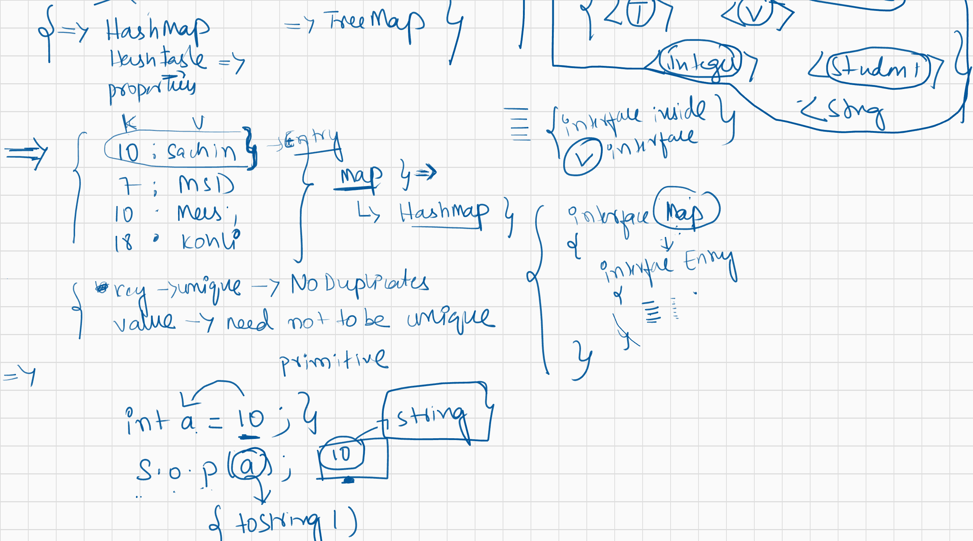
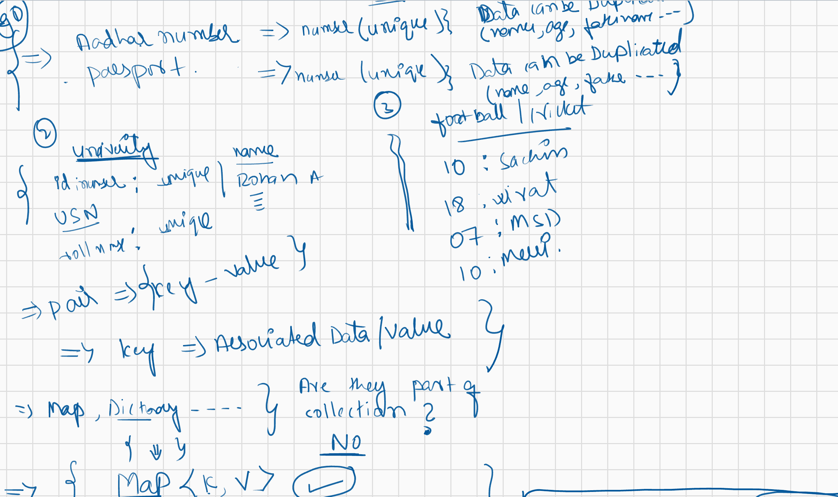
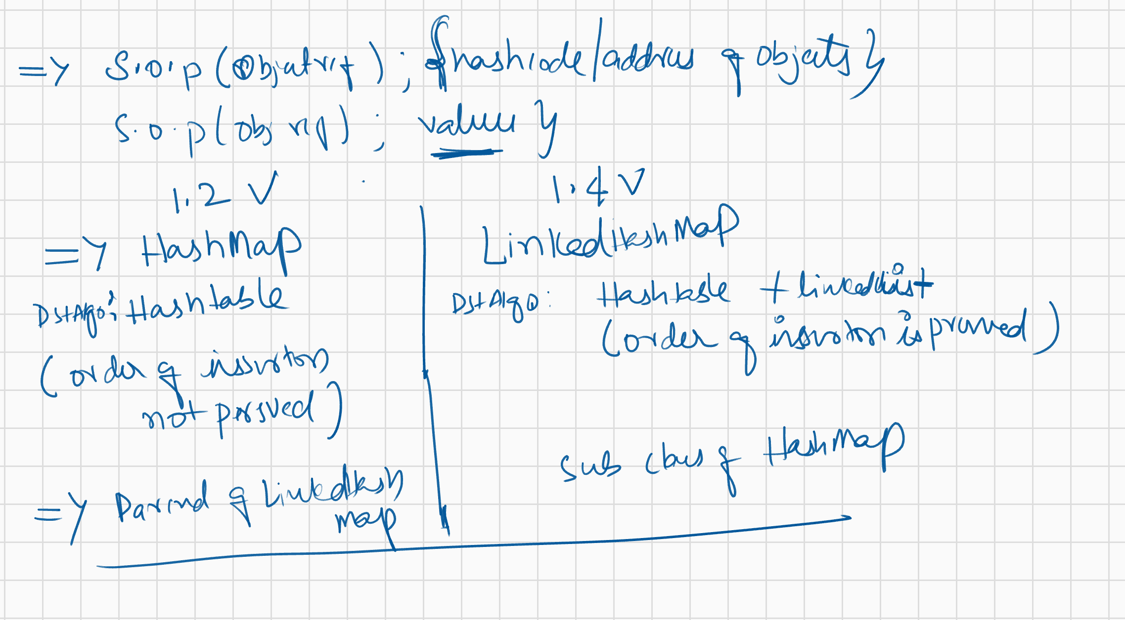
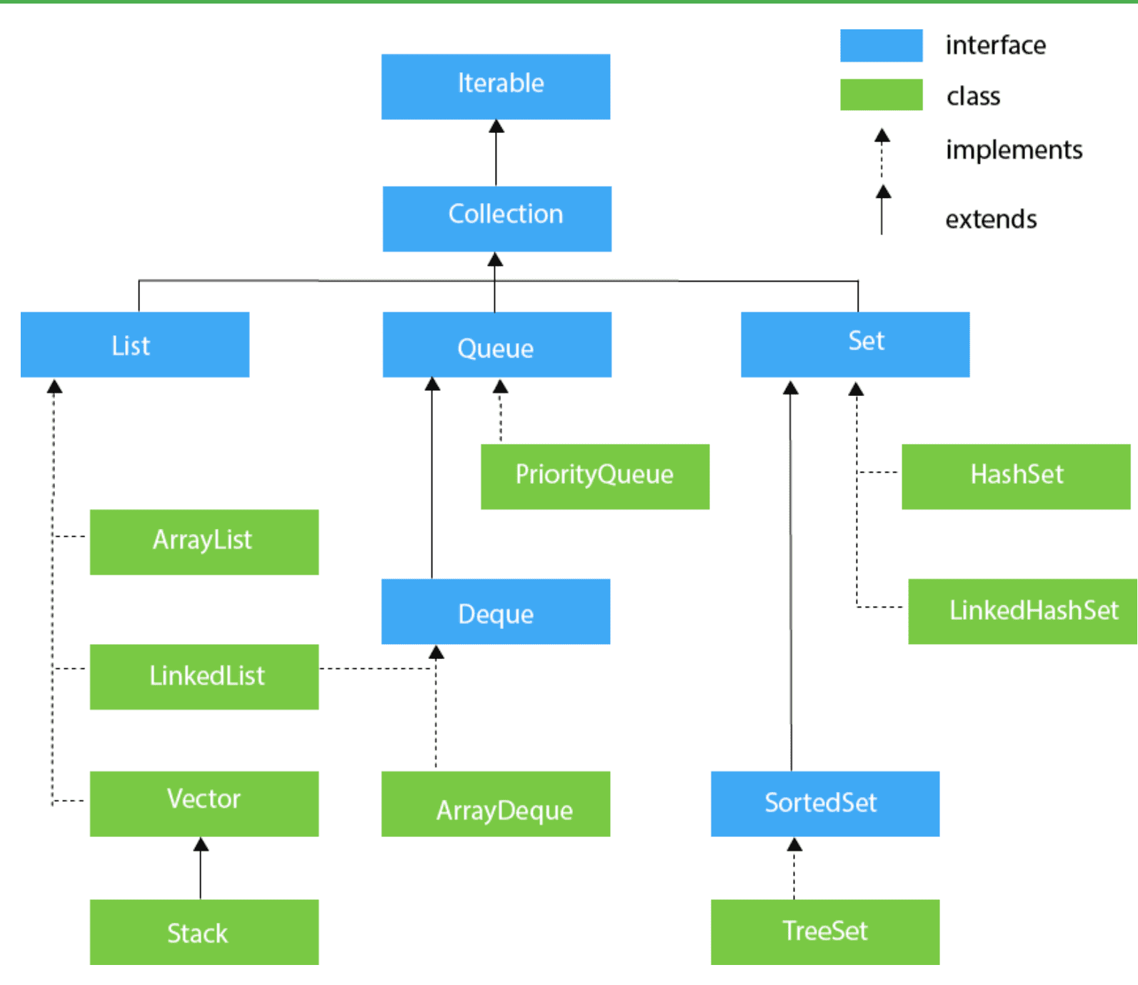
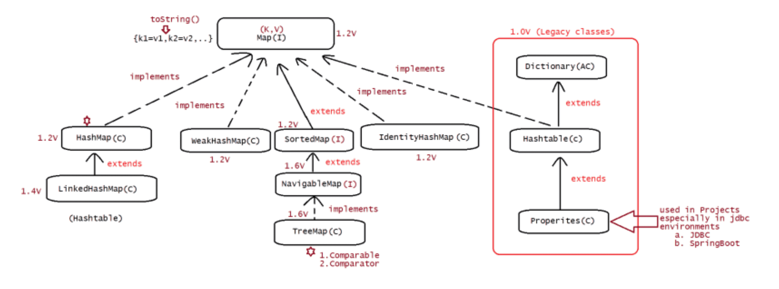
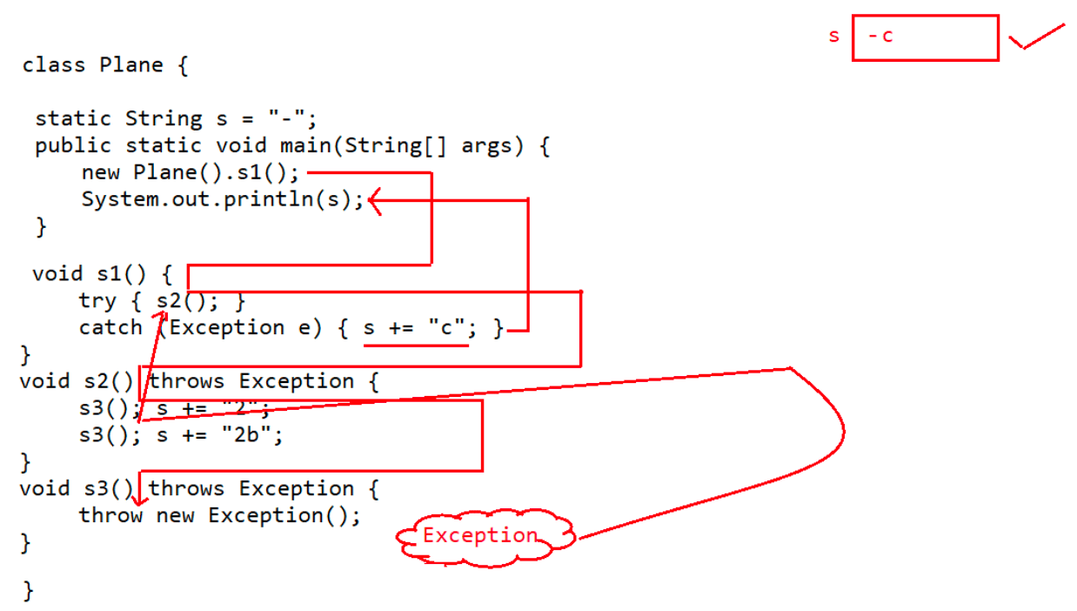

067 Maps and Interface new features

import java.io.FileNotFoundException;
import java.io.IOException;
abstract class Super {
public abstract void m1() throws IOException;
}
class Sub extends Super {
@Override
public void m1() throws IOException {
throw new FileNotFoundException();
}
}
public class Test {
public static void main(String[] args) {
Super s = new Sub();
try {
s.m1();
} catch (FileNotFoundException e) {
System.out.print("X");//X
} catch (IOException e) {
System.out.print("Y");
} finally {
System.out.print("Z");//Z
}
}
}
A. XZ
B. YZ
C. XYZ
D. compilationerror.
Answer: A
5.
import java.io.FileNotFoundException;
import java.io.IOException;
abstract class Super {
public abstract void m1() throws IOException;
}
class Sub extends Super {
@Override
public void m1() throws IOException {
throw new FileNotFoundException();
}
}
public class Test {
public static void main(String[] args) {
Super s = new Sub();
try {
s.m1();
} catch (FileNotFoundException e) {
System.out.print("M");
} finally {
System.out.print("N");
}
}}
A. MN
B. N
C. CompilationError
D. Program ends abruptly
Answer: C
6.
What will be the result of compiling and executing Test class?
public class Test {
private static void m1() {
System.out.println(1/0);//ArithmeticException: unchecked
}
public static void main(String[] args) {
try {
m1();
} finally {
System.out.println("A");
}
}
}
A. A is printed on the console and program terminates normally
B. A is printed on the console,stacktrace is printed and then program ends
normally
C. A is printed on the console,stacktrace is printed and then program ends
abruptly
D. Compilation Error.
Answer: C
Q>
A. throw
B. thrown
C. throws
D. catch
Which of the following keywords is used to manually throw an exception?
answerL A
Q>
What will be the result of compiling and executing Test class?
public class Test {
private static void m1() throws Exception {//Exception :: Checked(partially
checked)
throw new Exception();
}
public static void main(String[] args) {
try {
m1();
} finally {
System.out.println("A");
}
}
}
A. A is printed on the console and program terminates normallyB. A is printed on the console,stacktrace is printed and then program ends
normally
C. A is printed on the console,stacktrace is printed and then program ends
abruptly
D. Compilation Error.
Answer: D
Q>
Which of the following is a checked Exception?
A. ClassCastException ====> RunTimeException
B. FileNotFoundException ===> IOException (checkedException)
C. ExceptionInIntializerError ====> RunTimeException
D. RunTimeException======> parent of all uncheckedException
Answer: B
Q>
What will be the result of compiling and executing Test class?
public class Test {
private static String s;
public static void main(String[] args) {
try {
System.out.println(s.length());
} catch(NullPointerException | RuntimeException ex) {
System.out.println("DONE");
}
}
}
A. DONE
B. Executes succesfully but no output
C. CompilationError
D. NoOutput
Answer: C
Q>
What will be the result of compiling and executing Test class?
class Base {
public void m1() throws NullPointerException {//NullPointerException :
uncheckedException
System.out.println("Base: m1()");
}
}
class Derived extends Base {
public void m1() throws RuntimeException {//RuntimeException:
uncheckedException
System.out.println("Derived: m1()");
}
}
public class Test {
public static void main(String[] args) {
Base obj = new Derived();
obj.m1();
}
}
A. Base:m1()
B. Derived:m1()C. CompilationError in Derived class
D. CompilationError in Base class
Answer: B
Q>
Consider the following interface declaration:
public interface I1 {
void m1() throws java.io.IOException;//IOException : CheckedException
}
Which of the following incorrectly implements interface I1?
A. public class c1 implements I1{
public void m1(){}
}
B. public class c1 implements I1{
public void m1()throws java.io.FileNotFoundException{}
}
C.public class c1 implements I1{
public void m1()throws java.io.IOException{}
}
D.public class c1 implements I1{
public void m1()throws Exception{}//Since it is throwing Exception ,Parent
can't throw IOException, it should throw either Exception or Throwable
}
Answer: D
Q>.
Which of the following are Java Exception classes? Select 3 options.
A.ClassCastException
B. NullException
C. NumberFormatException
D. IllegalArgumentException
E. ArrayIndexException
Answer: A,C,D
Q>
Given Code:
import java.io.*;
class ReadTheFile {
static void print() { //Line 4
throw new IOException(); //Line 5
}
}
public class Test {
public static void main(String[] args) { //Line 10
ReadTheFile.print(); //Line 11
//Line 12
}
}
Which 2 changes are necessary so that code compiles successfully?
A. replace Line 4 with static void print() throws Exception
B. replace Line 4 with static void print() throws ThrowableC. replace Line 10 with public static void main(String[] args) throws IOException
D. Surrond Line 11 with
try{
ReadTheFile.print();
}catch(IOException | Exception e){}
E. Surrond Line 11 with
try{
ReadTheFile.print();
}catch(Exception e){}
F. Surrond Line 11 with
try{
ReadTheFile.print();
}catch(IOException e){}
Answer: A,E
.
import java.util.*;
class Employee
{
private int empid;
private String name;
private String empAddr;

@Override
public String toString()
{
return "hyder";
}

@Override
public void finalize()
{
System.out.println("Garbage Collector collected the object");
}
//setter
//getters
}
public class LaunchGC
{
public static void main(String[] args)throws Exception
{

Employee e=new Employee();
HashMap hm=new HashMap();
hm.put(e, "Hyder");
//Statements
//Statements
e=null; //eleigible for garbage collection
System.gc();//call to GC

Thread.sleep(4000);
System.out.println(hm);

}

}

import java.util.*;
class Employee1
{
private int empid;
private String name;
private String empAddr;

@Override
public String toString()
{
return "hyder";
}

@Override
public void finalize()
{
System.out.println("Garbage Collector collected the object");
}
//setter
//getters
}
public class LaunchGc2
{
public static void main(String[] args) throws Exception
{

Employee e=new Employee();
WeakHashMap hm=new WeakHashMap();
hm.put(e, "Hyder");
System.out.println(hm);
//Statements
//Statements
e=null; //eleigible for garbage collection
System.gc();//call to GC
Thread.sleep(4000);
System.out.println(hm);

}

}

import java.util.*;

class Ineuron
{
int i;
public Ineuron(int i)
{
this.i=i;
}
public String toString()
{
return i+ "";
}

}

public class LaunchHT {

public static void main(String[] args) {
// TODO Auto-generated method stub

Hashtable ht=new Hashtable();
ht.put(11, "Hyder");
ht.put(12, "Nitin");
System.out.println(ht);

Hashtable ht2=new Hashtable();
ht2.put(new Ineuron(11), "Hyder");
ht2.put(new Ineuron(12), "Nitin");
ht2.put(new Ineuron(13), "Navin reddy");

System.out.println(ht2);

/// equals(); HashMap
///==: IdentityHashMap

//Hashtable java1.0
//HashMap java 1.2

//Hashtable - synchronized (Multithreading not possible
//HashMap - non synchronized (Multithreading possible

//Hashtable - Thread safe
//HashMap - not safe

//Hashtable - Low performance
//HashMap - High performance
}

}
import java.util.*;
public class LaunchMapM
{
public static void main(String[] args)
{

Integer i1=new Integer(10);

Integer i2=new Integer(20);
Integer i3=new Integer(30);

HashMap hm=new HashMap();
hm.put(i1, "Rahul");
hm.put(i2, "Rohan");
hm.put(i3, "Rohit");

System.out.println(hm);

}

}
import java.util.*;
import java.util.Map.Entry;
class Student1
{
private String name;
private int age;
private String city;

public Student1(String name, int age, String city)
{
this.name=name;
this.age=age;
this.city=city;
}
public String getName() {
return name;
}
public int getAge() {
return age;
}
public String getCity() {
return city;
}
@Override
public String toString()
{
return name + " " +age + " " + city ;
}
}
public class LaunchMapsCom {

public static void main(String[] args) {
// TODO Auto-generated method stub

Student1 st1=new Student1("Rohan", 18, "Mumbai");
Student1 st2=new Student1("Rahul", 18, "Bengaluru");
Student1 st3=new Student1("Rohan", 19, "Delhi");

HashMap hm=new HashMap();
hm.put(1, st1);
hm.put(2, st2);
hm.put(3, st3);

System.out.println(hm);

//view

//entryset

Collection col=hm.values();
Iterator itr=col.iterator();
while(itr.hasNext())
{
System.out.println("value of Student : "+ itr.next());
}

System.out.println("**********************");

Set set=hm.keySet();

Iterator itr2=set.iterator();

while(itr2.hasNext())
{
System.out.println("Key of Student : "+ itr2.next());
}
System.out.println("********************");
Set bothData=hm.entrySet();
Iterator itr3=bothData.iterator();

while(itr3.hasNext())
{
Map.Entry data=(Entry) itr3.next();
System.out.println(data.getKey() + " : " + data.getValue());
}

}

}
import java.util.*;
import java.util.Map.Entry;
class Information
{
private String name;
private int age;
private String fatherName;
private String city;
public Information(String name , int age, String fatherName, String city)
{
this.name=name;
this.age=age;
this.fatherName=fatherName;
this.city=city;
}
public String getName() {
return name;
}
public int getAge() {
return age;
}
public String getFatherName() {
return fatherName;
}
public String getCity() {
return city;
}
@Override
public String toString()
{
return name + " " + age + " " + fatherName + " " + city;
}
}
//class Key {
// int key;
// public Key(int key)
// {
// this.key=key;
// }
//}

public class LaunchPassport
{
public static void main(String[] args)
{
Information info1= new Information("Rohan Sharma", 18, "Sharmaji", "Delhi");
Information info2= new Information("Hyder Abbas", 28, "Hussain Najafi", "Bengalauru");
Information info3= new Information("Nitin M", 29, "Manjunath", "Bengalauru");
// Key k=new Key(123);

HashMap hm=new HashMap();
hm.put(123, info1);//Entry
hm.put(111, info2);
hm.put(333, info3);
System.out.println("Welcome to Passport details APP");
Scanner scan=new Scanner(System.in);
System.out.println("Please enter the passport Number");
Integer k=scan.nextInt();

boolean flag=false;

Set set=hm.entrySet();
Iterator itr=set.iterator();
while(itr.hasNext())
{
Map.Entry passport=(Entry) itr.next();
Integer key=(Integer) passport.getKey();
if(k==key)
{
System.out.println(" : Info : "+ passport.getValue());
flag =true;
//break;
//System.exit(0);
}

}
if(flag==false)
{
System.out.println("Passport number not found");
}

}

}
import java.util.*;
public class LaunchTM {

public static void main(String[] args) {
// TODO Auto-generated method stub

TreeMap tm=new TreeMap();

tm.put(14, "Rohan");
tm.put(12, "Rohit");
tm.put(11, "Hyder");

System.out.println(tm);

}

}
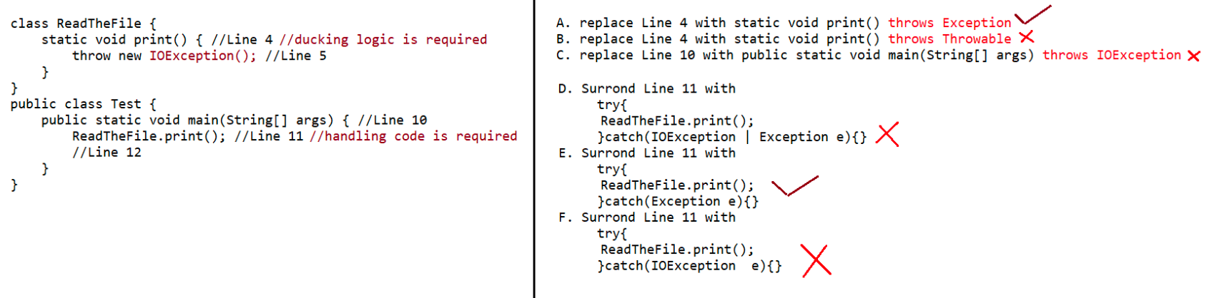
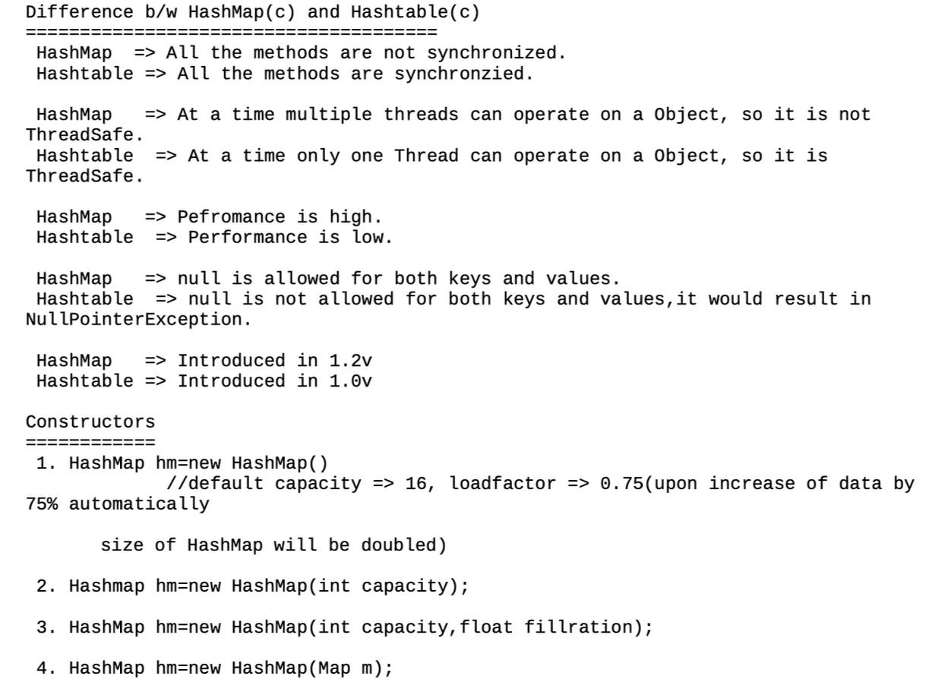
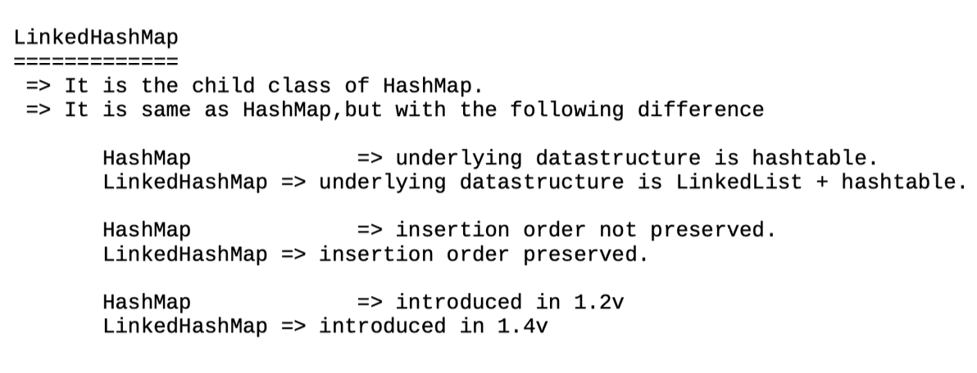
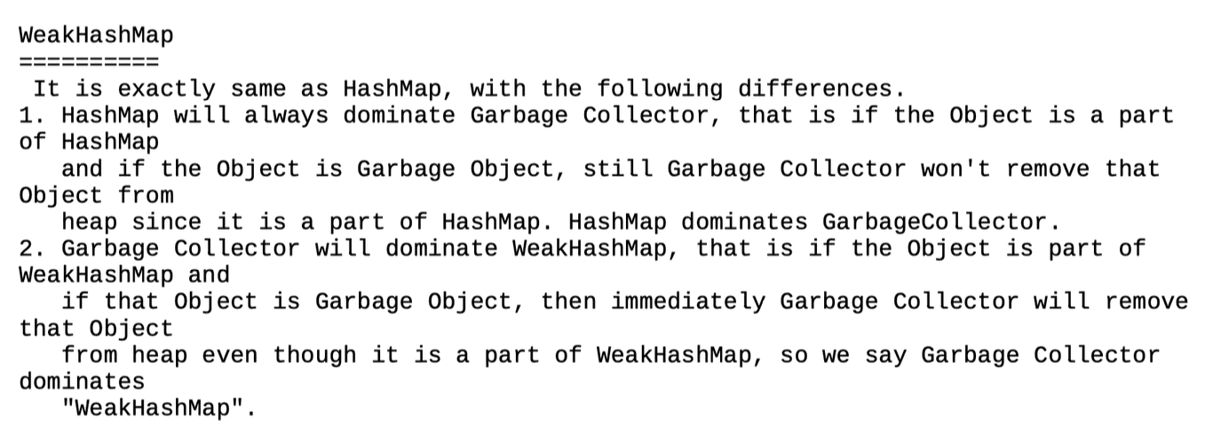
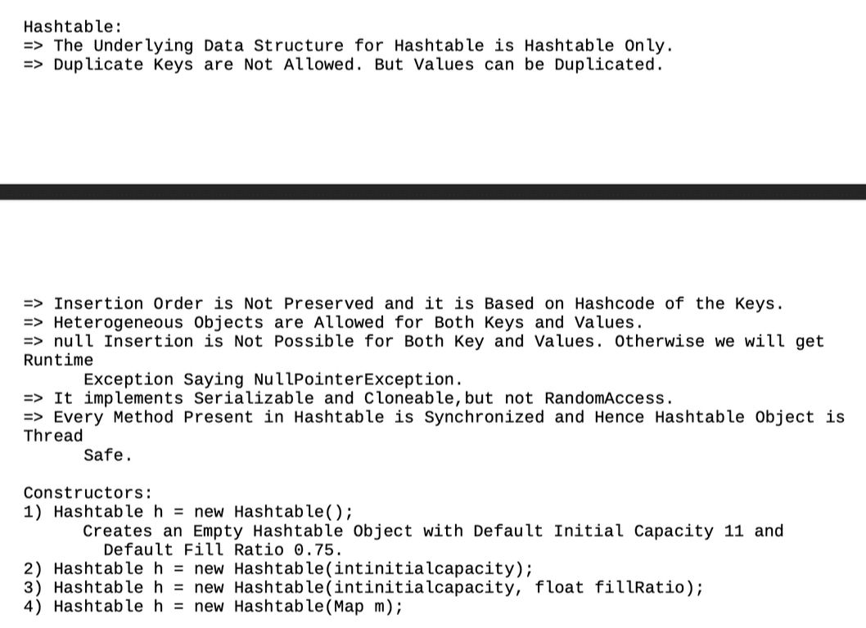
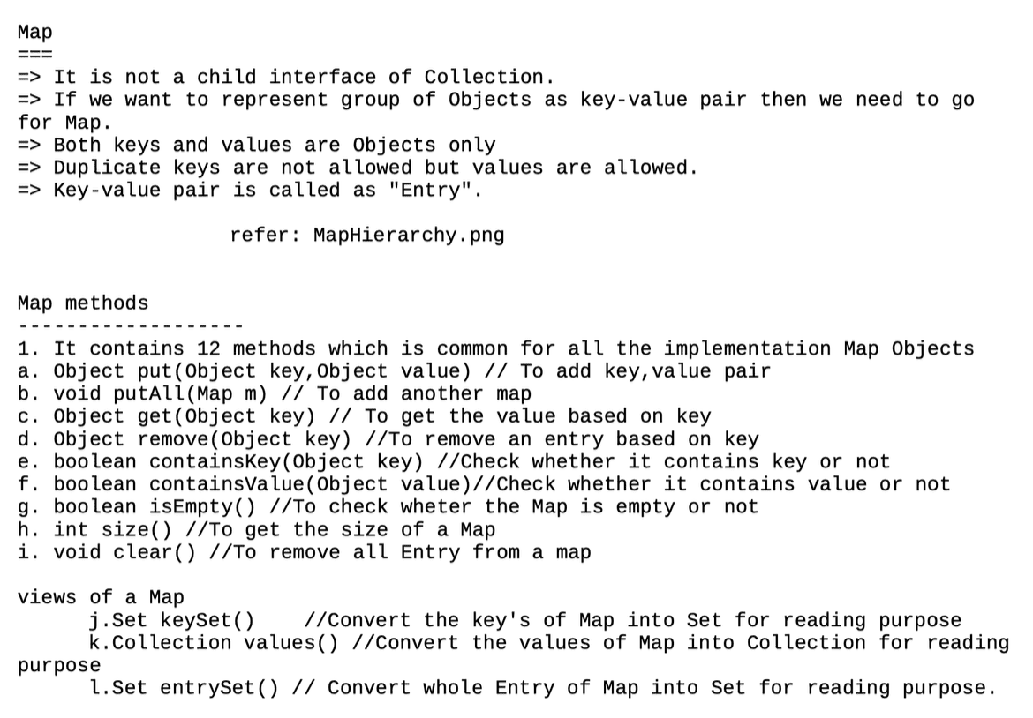
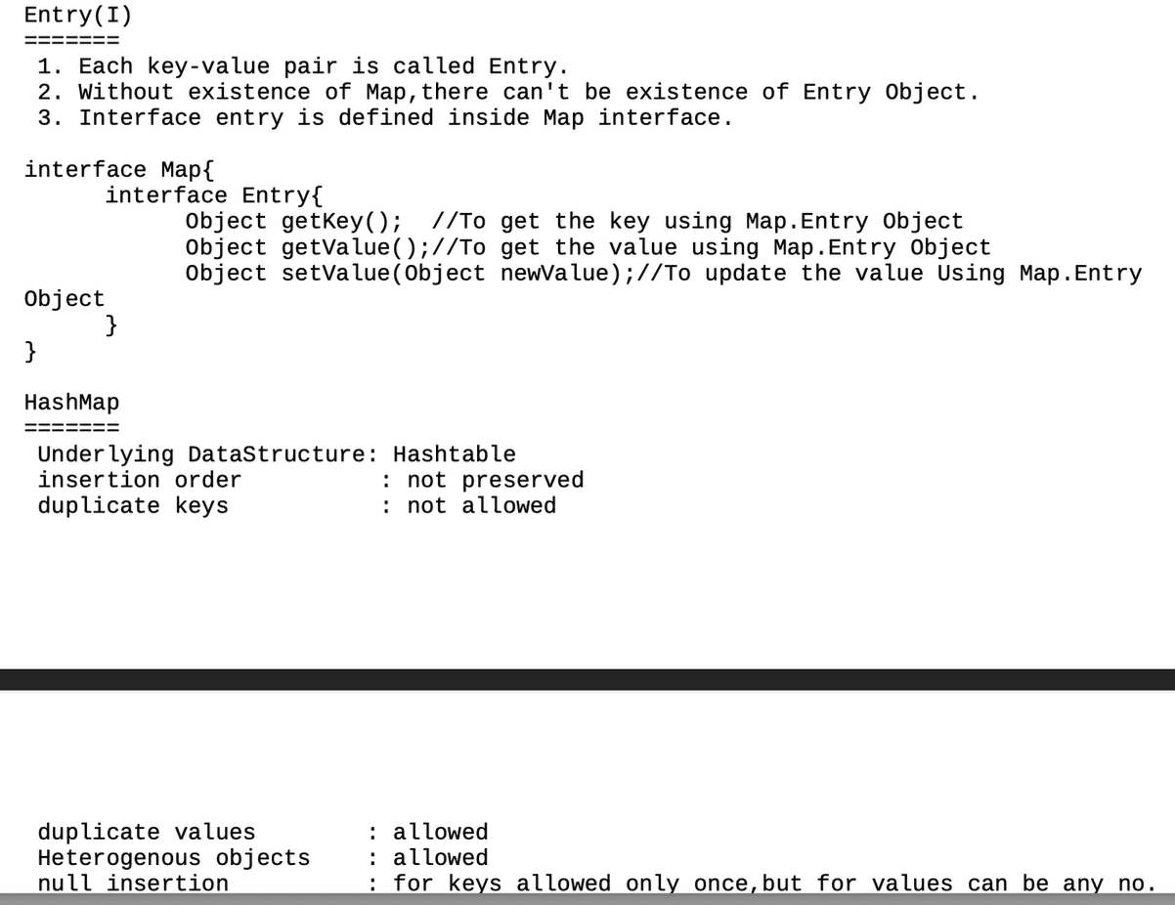

068 Introduction to Generics in Java

Agenda:
1. Introduction
2. Type-Safety
3. Type-Casting
4. Generic Classes
5. Bounded Types
6. Generic methods and wild card character(?)
7. Communication with non generic code
8. Conclusions
Deff : The main objective of Generics is to provide Type-Safety and to resolve
Type-Casting problems.
Case 1: Type-Safety
Arrays are always type safe that is we can give the guarantee for the type of
elements present inside array.
For example if our programming requirement is to hold String type of objects it is
recommended to use String array.
In the case of string array we can add only string type of objects by mistake if we
are trying to add any other type we will get
compile time error.
eg:
String name[] =new String[500];
name[0] = "Navin Reddy";
name[1] = "Haider";
name[2] = new Integer(100); //CE: incompatbile types found: java.lang.Integer
required: java.lang.String
That is we can always provide guarantee for the type of elements present inside
array and hence arrays are safe to use with respect to
type that is arrays are type safe.
But collections are not type safe that is we can't provide any guarantee for the
type of elements present inside collection.
For example if our programming requirement is to hold only string type of objects
it is never recommended to go for ArrayList.
By mistake if we are trying to add any other type we won't get any compile time
error but the program may fail at runtime.
eg:
ArrayList al =new ArrayList();
al.add("NavinReddy");
al.add("Haider");
al.add(new Integer(10));
;;;
;;;
;;;
String name1 = (String)al.get(0);
String name2 = (String)al.get(1);
String name3 = (String)al.get(2);//Exception in thread "main" ::
java.lang.ClassCastException
java.lang.Integer cannot
be cast to java.lang.String
Hence we can't provide guarantee for the type of elements present insidecollections that is collections are not safe to use with
respect to type.
Case 2: Type-Casting
In the case of array at the time of retrieval it is not required to perform any
type casting.
eg::
String name[] =new String[500];
name[0] = "Navin Reddy";
name[1] = "Haider";
;;;;
;;;;
String data =name[0];//here type casting is not required.
But in the case of collection at the time of retrieval compulsory we should perform
type casting otherwise we will get compile time error.
eg::
ArrayList al =new ArrayList();
al.add("NavinReddy");
al.add("Haider");
String name1= al.get(0);//CE: incompatible types : found : java.lang.Object
required:
java.lang.String
String name1=(String) al.get(0);//At the time of retrieval type casting is
madantory
That is in collections type casting is bigger headache.
To overcome the above problems of collections(type-safety, type casting)sun people
introduced generics concept in 1.5v
hence the main objectives of generics are:
1. To provide type safety to the collections.
2. To resolve type casting problems.
To hold only string type of objects we can create a generic version of ArrayList as
follows.
ArrayList<String> al =new ArrayList<String>();
al.add("NavinReddy");
al.add(10);//CE: can't find symbol
symbol: method add(int)
location : class
java.util.ArrayList<java.lang.String>
al.add(10)
For this ArrayList we can add only string type of objects by mistake if we are
trying to add any other type we will get compile time error
that is through generics we are getting type safety.
At the time of retrieval it is not required to perform any type casting we can
assign elements directly to string type variables.
eg:
ArrayList<String> al =new ArrayList<String>();
al.add("NavinReddy");
;;;;
;;;;
String name =al.get(0);//type casting is not required as it is an TypeSafeThat is through generic syntax we can resolve type casting problems.
Conclusions
=========
type
1. Polymorphism concept is applicable only for the base type but not for parameter
[usage of parent reference to hold child object is called polymorphism].
eg: ArrayList<String> al =new ArrayList<String>();
List<String> al =new ArrayList<String>();
Collection<String> al =new ArrayList<String>();
Collection<Object> al =new ArrayList<String>();//CE: incompatible types
2.
Collections concept applicable only for objects , Hence for the parameter type we
can use any class or interface name but not primitive
value(type).Otherwise we will get compile time error.
eg: ArrayList<int> al =new ArrayList<int>();//CE: unexcpected type
found:primitive
required:
reference

070 Enum and Annotations
Generic classes:
Until 1.4v a non-generic version of ArrayList class is declared as follows.
Example:
class ArrayList{
add(Object o);
Object get(int index);
}
add() method can take object as the argument and hence we can add any type of
object to the ArrayList.
Due to this we are not getting type safety.
The return type of get() method is object hence at the time of retrieval compulsory
we should perform type casting.
But in 1.5v a generic version of ArrayList class is declared as follows.
|=> Type parameter
class ArrayList<T>{
add(T t);
T get(int index)
}
Based on our requirement T will be replaced with our provided type.
For Example to hold only string type of objects we can create ArrayList object as
follows.
Example:
ArrayList<String> l=new ArrayList<String>();
For this requirement compiler considered ArrayList class is
Example:
class ArrayList<String>{
add(String s);
String get(int index);
}
add() method can take only string type as argument hence we can add only string
type of objects to the List.
By mistake if we are trying to add any other type we will get compile time error.
eg#1.
ArrayList<String> al =new ArrayList<String>();
al.add("NavinReddy");
al.add(10);//CE: can't find symbol
symbol: method add(int)
location : class
java.util.ArrayList<java.lang.String>
al.add(10)
eg#2.
ArrayList<String> al =new ArrayList<String>();
al.add("NavinReddy");
String name = al.get(0);//type casting is not requried
Hence through generics we are getting type safety.
At the time of retrieval it is not required to perform any type casting we can
assign its values directly to string variables.
In Generics we are associating a type-parameter to the class, such type of
parameterised classes are nothing but Generic
classes.Generic class : class with type-parameter.
Based on our requirement we can create our own generic classes also.
Example:
class Account<T>
{}
Account<Gold> g1=new Account<Gold>();
Account<Silver> g2=new Account<Silver>();
Example:
class Gen<T>{
T obj;
Gen(T obj){
this.obj=obj;
}
public void show(){
System.out.println("The type of object
is :"+obj.getClass().getName());
}
public T getObject(){
return obj;
}
}
class GenericsDemo{
public static void main(String[] args){
Gen<Integer> g1=new Gen<Integer>(10);
g1.show();
System.out.println(g1.getObject());
Gen<String> g2=new Gen<String>("iNeuron");
g2.show();
System.out.println(g2.getObject());
Gen<Double> g3=new Gen<Double>(10.5);
g3.show();
System.out.println(g3.getObject());
}
}
Output:
The type of object is: java.lang.Integer
10
The type of object is: java.lang. String
iNeuron
The type of object is: java.lang. Double
10.5
Note: To get the underlying object of any reference type we use a method called
ref.getClass().getName()
eg1
interface Calculator{}
class Casio implements Calculator{}
class Quartz implements Calculator{}
class Kadio implements Calculator{}Calculator c1 =new Casio();
System.out.println(c1.getClass().getName());//Casio
Calculator c2 =new Quartz();
System.out.println(c2.getClass().getName());//Quartz
Calculator c3 =new Kadio();
System.out.println(c3.getClass().getName());//Kadio
Bounded types
--------------------
We can bound the type parameter for a particular range by using extends keyword
such types are called bounded types.
Example 1:
class Test<T>
{}
Test <Integer> t1=new Test< Integer>();
Test <String> t2=new Test < String>();
Here as the type parameter we can pass any type and there are no restrictions hence
it is unbounded type.
Example 2:
class Test<T extends X>
{}
If x is a class then as the type parameter we can pass either x or its child
classes.
If x is an interface then as the type parameter we can pass either x or its
implementation classes.
eg#1.
class Test <T extends Number>{}
class Demo{
public static void main(String[] args){
Test<Integer> t1 = new Test<Integer>();
Test<String> t2 = new Test<String>(); //CE
}
}
eg#2.
class Test <T extends Runnable>{}
class Demo{
public static void main(String[] args){
Test<Thread> t1 = new Test<Thread>();
Test<String> t2 = new Test<String>(); //CE
}
}
Keypoints about bounded types
------------------------------------------
=> We can't define bounded types by using implements and super keyword
=> But implements keyword purpose we can replace with extends keyword.
eg: class Test<T implements Runnable>{}//invalid
class Test<T super String>{}//invalid

@interface CricketPlayer
{
//@ --> its not interface but its Annotation being created
String country();
int runs();
}

class ViratKohli
{
private int innings;
private String name;

public int getInnings() {
return innings;
}
public void setInnings(int innings) {
this.innings = innings;
}
public String getName() {
return name;
}
public void setName(String name) {
this.name = name;
}

}
public class LaunchAnn2 {

public static void main(String[] args) {

ViratKohli vk=new ViratKohli();
vk.setInnings(300);
vk.setName("VK");

System.out.println(vk.getInnings());
System.out.println(vk.getName());

}

}
// Annotation java 5

//@CricketPlayer
//class Virat
//{
//
//}

//Annotation --> Annotation --> parent of all Annotations
//Annotation ---> Built in
// ----> Custome (our Own)

// Annotation -->
//1) class
//2) interface
//3) method
// 4) fields // instance var
//5 ) local variables
// 6) Consrtuctor
// 7) Parameters
// 8) enum

@FunctionalInterface
interface Trial
{
int getNum();
//void disp();
}

class JavaLearning
{
public void disp1()
{
System.out.println("Parent disp");
}
}

class Focus extends JavaLearning
{
@Override
public void disp1()
{
System.out.println("Focus is key");
}
}

public class LaunchAnno {

public static void main(String[] args) {
// TODO Auto-generated method stub

Trial t= ()->
{
return 10;
};

}

}

//NORTH SOUTH EAST WEST
//MALE FEMALE OTHERS
// SUN MON TUE WED THU FRI SAT
//JAN FEB MAR ------ DEC
// PASS FAIL NR
// so on.......

enum Result1
{
PASS, FAIL, NR; // static final
// fields --> instance var --> properties
//methods
//Constructor
}
//enum Gender
//{
// MALE, FEMALE, OTHERS;
//}
//enum Compass
//{
// NORTH, SOUTH, EAST, WEST;
//}

//class Demo
//{
// //final int PASS=35;
// //PASS --> error
//}

// separte .clas for every enum

public class LaunchEnum
{
// enum Gender
// {
// MALE, FEMALE, OTHERS;
// }

public static void main(String[] args) {
// TODO Auto-generated method stub

}

}

enum Result
{
PASS, FAIL, NR; //static final

//PASS --> public static final Result PASS=new Result();
//FAIL --> static final Result FAIL =new Result();
//NR ---> static final Result NR=new Result();

Result()
{
System.out.println("Constructor is called");
}
}

public class LaunchEnum2
{

public static void main(String[] args)
{
Result res=Result.PASS;
System.out.println(res);

Result resArr[]=Result.FAIL.values();

for(Result haider:resArr)
{
System.out.println(haider.ordinal() + " : " + haider.name());
}

}

}
enum Course
{
JAVA, JEE, SPRINGBOOT, HYDER;

int courseId;

Course()
{
System.out.println("Constructor");
}

void setCourseId(int courseId)
{
this.courseId=courseId;
}
int getCourseId()
{
return courseId;
}
}

public class LaunchEnum3
{
public static void main(String[] args)
{
Course.JAVA.setCourseId(10);

int cid=Course.JAVA.getCourseId();
System.out.println(cid);

}

}

